**Instructions**

Thank you for your planning effort. This template is created for use by local entities in Riverside County by the County of Riverside, Emergency Management Department. Contact the County of Riverside, Emergency Management Department with any questions at 951-358-7100.

Elements of the County of Riverside EOP have been included throughout the plan in an effort to improve coordination with Operational Area partners.

The language from the County EOP may be included, modified, or deleted as desired by local entities. County of Riverside EOP language will be visually distinguished with a blue box like the one around this paragraph.

Highlighted prompts in the document are meant to prompt inclusion of local entity information. Local information will need to be added in addition to highlighted prompts as well.

Training and exercises with staff of the local entity is necessary beyond the plan being created in written form.

Delete this page in your final EOP after using the template below

Following adoption of your plan, please provide the Operational Area with a copy by calling the County Emergency Management Department at 951-358-7100 to schedule submission via mail or email:

* One copy of the adopted plan
* One copy of the adoption documents such as letter, resolution, and leadership signatures

Entity Logo

Entity Name

Emergency Operations Plan

Portions of this document may contain sensitive information pertaining to the deployment, mobilization, and tactical operations of Entity in response to emergencies and disasters. The vast majority of this plan is available for public review. Refer any request for a copy of this document to \_contact info

# FORWARD

Date

Enclosed is the revised Entity Emergency Operations Plan (EOP). This plan is designed as a reference and guidance document, and is the foundation for response and recovery operations for Entity and is meant to coordinate with the Riverside County Operational Area EOP and EOC to facilitate effective response to any emergency.

This plan establishes the emergency organization, assigns tasks, and specifies policies and general procedures during both response and recovery. It also provides for coordination with the County as the OA Lead Agency. This plan includes the critical elements of the Standardized Emergency Management System, the National Incident Management System, the Incident Command System, and the National Response Framework.

This Emergency Operations Plan can be used to coordinate localized emergencies as well as catastrophic disasters. The plan will be reviewed and exercised periodically and revised as necessary to meet changing conditions.

Entity gives full support to this plan and urge all officials, employees, and citizens, individually and collectively, to do their share in emergency preparedness, response, and recovery efforts.

This Emergency Operations Plan will become effective upon resolution/ordinance with concurrence by signatures of Entity leadership below.

Official Signatory

XXXXXX

# Copy of Resolution / Ordinance Entity insert if applicable

# Plan Concurrence

As a designated officials in an emergency management effort, and having reviewed this Emergency Operations Plan, I hereby sign this concurrence page to show my approval of the plan and its contents.

Entity change as applicable

|  |  |  |
| --- | --- | --- |
| **Department/TITLE** | **NAME** | **SIGNATURE** |
| Administrative Services |  |  |
| Animal Services |  |  |
| Building and Safety |  |  |
| City Manager |  |  |
| City Attorney |  |  |
| City Clerk |  |  |
| Code Enforcement |  |  |
| Community Development |  |  |
| Economic Development |  |  |
| Financial Services |  |  |
| Fire |  |  |
| Human Resources |  |  |
| Library Services |  |  |
| Media |  |  |
| Parks & Community Services |  |  |
| Planning |  |  |
| Police |  |  |
| Public Works |  |  |

## Plan Development and Maintenance

Entity/Title is responsible for writing, reviewing, and updating of the EOP.

The updates will include new information such as changing of phone numbers and revisions of relevant standard operational procedures or organizational structure. A record of changes and revisions will be maintained. All changes to the plan will be distributed as shown on the plan distribution list. Revisions to the plan will be approved by Entity.

## 

## 

## Distribution List

This distribution list names the departments or agencies receiving copies of the Entity Emergency Operations Plan. The plan will be distributed in a printed version.

|  |  |  |  |
| --- | --- | --- | --- |
| **Organization** | **#** | **Organization** | **#** |
| Cal OES, Southern Region | 1 | Tribal Governments(names, titles) | 1 each |
| City Council | 1 | Public Utilities (names, titles) | 1 each |
| County of Riverside Supervisors | 5 | School Districts (names, titles) | 1 each |
| County Chief Executive Officer | 1 | Special Districts (names, titles) | 1 each |
| County Library Reference Desk | 1 |  |  |
| County Office of Education | 1 each |  |  |
| Fire Protection Districts | 1 each |  |  |

|  |  |  |  |
| --- | --- | --- | --- |
| **Department** | **#** | **Department** | **#** |
| Administrative Services | 1 | Parks & Community Services | 1 |
| Animal Services | 1 | Planning | 1 |
| Building and Safety | 1 | Police | 1 |
| City Manager | 1 | Public Works | 1 |
| City Attorney | 1 |  |  |
| City Clerk | 1 |  |  |
| Code Enforcement | 1 |  |  |
| Community Development | 1 |  |  |
| Economic Development | 1 |  |  |
| Financial Services | 1 |  |  |
| Fire | 1 |  |  |
| Human Resources | 1 |  |  |
| Library Services | 1 |  |  |
| Media | 1 |  |  |

## Record of Revisions

The Entity/Title will maintain the official copy of the EOP and use the record of revisions table below to track changes to the EOP.

|  |  |  |  |
| --- | --- | --- | --- |
| **Change No.** | **Description** | **Change Date** | **Approved By** |
|  |  |  |  |
|  |  |  |  |
|  |  |  |  |
|  |  |  |  |

# 

# TABLE of CONTENTS

[**FORWARD iii**](#h.gjdgxs)

[**Plan Concurrence v**](#h.30j0zll)

[Plan Development and Maintenance vi](#h.1fob9te)

[Distribution List vi](#h.2et92p0)

[Record of Revisions vii](#h.tyjcwt)

[**Plan Approval Resolution viii**](#h.3dy6vkm)

[**TABLE of CONTENTS ix**](#h.1t3h5sf)

[**BASIC PLAN 1**](#h.4d34og8)

[**Section 1.0** **Administrative Features 1**](#h.2s8eyo1)

[1.1 Plan Format](#h.17dp8vu) [1](#h.17dp8vu)

[1.2 Purpose and Scope 1](#h.3rdcrjn)

[1.3 Riverside County/OA EOP Implementation 2](#h.35nkun2)

[1.4 Authorities and References 2](#h.1ksv4uv)

[*Federal 2*](#h.2jxsxqh)

[*State 3*](#h.3j2qqm3)

[*County 3*](#h.4i7ojhp)

[1.5 Relationship to Other Plans and References 4](#h.1ci93xb)

[1.6 Standard Operating Procedures/Guidelines (SOPs/SOGs) 5](#h.3whwml4)

[**Section 2.0** **Situation and Assumptions 7**](#h.2bn6wsx)

[2.1 General Description 7](#h.qsh70q)

[2.2 Geography 8](#h.3as4poj)

[2.3 Hazard Analysis 8](#h.1pxezwc)

[Severity Rating Table 10](#h.2p2csry)

[Figure 1](#h.147n2zr) [Entity Map10](#h.147n2zr)

[2.4 Hazard Situation and Summaries 11](#h.3o7alnk)

[*2.4.1* *Earthquake Hazards 11*](#h.23ckvvd)

[*2.4.2*](#h.32hioqz)[*Public Health Emergencies*](#h.nmf14n)

[*2.4.*](#h.32hioqz)*3* [*Wildland Fires 14*](#h.32hioqz)

[*2.4.*](#h.41mghml)*4**Electrical Failure and Utility Outages*

2.4.5 [*Flooding 16*](#h.41mghml)

[*ARKStorm 18*](#h.3fwokq0)

[*2.4.*](#h.4f1mdlm)*6* [*Transportation Hazards 20*](#h.4f1mdlm)

[*2.4.*](#h.19c6y18)*7* [*Extreme Weather and Drought 21*](#h.19c6y18)

[*2.4.*](#h.3tbugp1)*8* [*Hazardous Materials Incident 23*](#h.3tbugp1)

[*2.4.*](#h.28h4qwu)*9* [*Insect Infestation 24*](#h.28h4qwu)

[*2.4.10* *Domestic Security Threats 27*](#h.2lwamvv)

[*2.4.11* *Nuclear Incidents 30*](#h.111kx3o)

[*2.4.12* *Toxic Pollution 31*](#h.206ipza)

[*2.4.13*](#h.4k668n3)[*Pipeline and Aqueduct Incidents 31*](#h.4k668n3)

[2.5 Planning Assumptions 32](#h.2zbgiuw)

[**Section 3.0** **Concept of Operations 34**](#h.1egqt2p)

[3.1 Phases of Emergency Management 34](#h.2dlolyb)

[*3.1.1* *Preparedness Phase 34*](#h.sqyw64)

[*3.1.2* *Response Phase 36*](#h.3cqmetx)

[*3.1.3* *Recovery Phase 38*](#h.1rvwp1q)

*3.1.4* *Mitigation Phase 38*

[3.2 Presidential Policy Directive 8- the National Preparedness Goal 39](#h.4bvk7pj)

[3.3 National Incident Management System (NIMS) 39](#h.2r0uhxc)

[3.4 Standardized Emergency Management System (SEMS) 39](#h.1664s55)

[3.5 Incident Command System (ICS) 40](#h.3q5sasy)

[3.6 SEMS Organizational Levels 40](#h.25b2l0r)

[*3.6.1* *Field Response Level 40*](#h.kgcv8k)

[*3.6.2* *Local Government Level 41*](#h.34g0dwd)

[*3.6.3*](#h.1jlao46) [*Operational Area Level 42*](#h.2iq8gzs)

[*3.6.*](#h.xvir7l)*4* [*Regional Level 43*](#h.xvir7l)

[Figure Cal OES Mutual Aid and Administrative Regions](#h.4du1wux)

[*3.6.*](#h.3hv69ve)*5* [*State Level 44*](#h.3hv69ve)

[*3.6.*](#h.1x0gk37)*6* [*Federal Level 44*](#h.1x0gk37)

[3.7 SEMS Organization 44](#h.2w5ecyt)

[3.8 Field Level](#h.3vac5uf) Interface with the EOC [45](#h.3vac5uf)

[*3.8.1* *Field/EOC Communications and Coordination 46*](#h.pkwqa1)

[*3.8.2* *Field/EOC Direction and Control Interface*](#h.39kk8xu)[*46*](#h.39kk8xu)

[*3.8.3* *Field/EOC Coordination with Department Operations Centers (DOCs) 46*](#h.1opuj5n)

[3.9 EOC Action Plans 46](#h.48pi1tg)

[3.10 After Action/Corrective Action Reports 47](#h.2nusc19)

[3.11 Coordination with Emergency Response Levels 48](#h.3mzq4wv)

[*3.11.1* *Coordination with Field Response Level 48*](#h.2250f4o)

[*3.11.2* *Coordination with Riverside Operational Area 48*](#h.319y80a)

[*3.11.3* *Coordination with Special Districts 48*](#h.40ew0vw)

[*3.11.4* *Coordination with Volunteer and Private Sector Agencies 49*](#h.upglbi)

[3.12 Statewide Emergency Management 49](#h.1tuee74)

[*3.12.1* *California Master Mutual Aid Agreement 51*](#h.184mhaj)

[*3.12.2* *Emergency Management Assistance Compact (EMAC) 51*](#h.3s49zyc)

[*3.12.3* *Mutual Aid System 51*](#h.279ka65)

[*3.12.4* *Mutual Aid Coordinators 52*](#h.1ljsd9k)

[Figure Discipline Specific Mutual Aid System 52](#h.45jfvxd)

[*3.12.5* *Mutual Aid Agreements 53*](#h.3jtnz0s)

[*3.12.6* *Riverside County/OA Mutual Aid Requests 53*](#h.1yyy98l)

[3.13 Riverside County Emergency Organization 53](#h.1d96cc0)

[Figure 9 Riverside County Emergency Organization 54](#h.2ce457m)

[*3.13.1* *Emergency Proclamations 55*](#h.rjefff)

[*3.13.2* *State of Emergency 55*](#h.4anzqyu)

[*3.13.3* *State of War Emergency 56*](#h.14ykbeg)

[3.14 Continuity of Government 56](#h.243i4a2)

[*3.14.1* *Alternate Seat of Government 57*](#h.j8sehv)

[*3.14.2* *Lines of Succession 58*](#h.338fx5o)

[*3.14.3* *Departmental Lines of Succession 59*](#h.1idq7dh)

[*3.14.3* *Vital Record Retention 62*](#h.3gnlt4p)

[3.15 Training, Documentation and Exercises 63](#h.1vsw3ci)

[3.16 Requirements of the Americans with Disabilities Act 64](#h.4fsjm0b)

[*3.16.1* *People with Disabilities and Others with Access and Functional Needs 65*](#h.2uxtw84)

*3.16.2* *California Office for Access and Functional Needs 66*

[3.17 Animal Care Considerations 66](#h.1a346fx)

[3.18 Communications and Warning 67](#h.3u2rp3q)

[*3.18.1*](#h.2981zbj)  [*Emergency Alert System (EAS) 67*](#h.2981zbj)

[*3.1.8.1.1 Integrated Public Alert and Warning System 70*](#h.1nia2ey)

[*3.18.2* *National Warning System (NAWAS) 71*](#h.47hxl2r)

[*3.18.3* *California State Warning Center (CSWC) 71*](#h.11si5id)

[*3.18.4* *Operational Area Satellite Information System (OASIS) 72*](#h.20xfydz)

[*3.18.5* *Emergency Digital Information System (EDIS) 72*](#h.4kx3h1s)

[*3.18.6* *Emergency News Network (ENN) 73*](#h.302dr9l)

[*3.18.7* *Western County Disaster Net 73*](#h.1f7o1he)

[*3.18.8*  *Satellite Telephones 73*](#h.3z7bk57)

[*3.18.9*  *Radio Amateur Civil Emergency Services (RACES) 73*](#h.2eclud0)

[*3.18.10*  *Riverside County Early Warning Notification System (EWNS) 73*](#h.thw4kt)

[*3.18.11* *Social Media 74*](#h.3dhjn8m)

[*3.18.12* *Relay Services 74*](#h.1smtxgf)

[**4.0** **Riverside County Recovery Operations 76**](#h.4cmhg48)

[*4.0.1* *Short Term Recovery*](#h.16x20ju)[*76*](#h.16x20ju)

[*4.0.2* *Long Term Recovery 76*](#h.3qwpj7n)

[4.1 SEMS Recovery Organization 77](#h.261ztfg)

[4.2 Damage Assessment 77](#h.l7a3n9)

*4.2.1* *Safety Concerns 78*

[*4.2.2* *Structural Damage 78*](#h.356xmb2)

[4.3 Recovery Activities 78](#h.1kc7wiv)

[*4.3.1* *List of Damages 79*](#h.44bvf6o)

[4.4 Recovery Reporting and Documentation 79](#h.2jh5peh)

[*4.4.1* *After-Action Reporting 79*](#h.ymfzma)

[*4.4.2* *Recovery Documentation 79*](#h.3im3ia3)

[4.5 Disaster Assistance 80](#h.1xrdshw)

[*4.5.1* *Government Assistance to Individuals 80*](#h.4hr1b5p)

[*4.5.2* *Federal Programs 80*](#h.2wwbldi)

[4.6 Non Profit Volunteer Charitable Organizations 81](#h.1c1lvlb)

[4.7 Public Assistance 81](#h.3w19e94)

[*4.7.1* *Federal – Robert T Stafford Disaster Relief Act of 1974 82*](#h.2b6jogx)

[*4.7.2* *Disaster Field Office 82*](#h.qbtyoq)

[*4.7.3* *State – California Disaster Assistance Act (CDAA) 83*](#h.3abhhcj)

[4.8 Hazard Mitigation Grant Programs 83](#h.1pgrrkc)

[Appendix A – Glossary of Terms 86](#h.3nqndbk)

[Appendix B – Resources 98](#h.22vxnjd)

[Appendix C – Contact List 100](#h.i17xr6)

[Appendix D – Supporting Documentation 102](#h.320vgez)

# BASE PLAN

# Section 1.0 Administrative Features

## 1.1 Plan Format

Instructions: Entity insert if applicable and as desired.

The EOP consists of the Base Plan, Appendices, and Emergency Support Functions:

* Base Plan includes:
  + Introduction and administrative features; concept of operations including the principles and methods used to carry out emergency operations; hazards and threats to the county to provide a rationale for prioritizing emergency preparedness actions for specific hazards; and recovery and mitigation operations.
* Appendices include:
  + Glossary; resources; contact lists; supporting documentation; EOC Operations; Department Emergency Operations
* Emergency Support Function Annexes:
  + The annexes represent a set of specific protocols that are complementary to the EOP and will be used during specific, significant emergency situations that require unique planning and coordination beyond the all hazards approach within the Basic Plan (example, floods).

## 1.2 Purpose and Scope

This Emergency Operations Plan (EOP) applies to the Entity. The EOP addresses the planned response to extraordinary situations associated with natural disasters and/or human caused incidents including both peacetime and national security operations. The plan focuses on coordinating mutual aid and also provides an overview of the operational concepts relating to various emergency situations, identifies components of the emergency response, and describes the overall responsibilities of the OA for supporting OA Members in protecting life and property.

The Riverside County/OA (Operational Area) EOP provides a consistent framework for emergency management and includes County management staff and employees, federal, state and city governments, tribal governments, partner agencies, special districts, and school districts that serve Riverside County residents, and private and volunteer organizations involved in emergencies. This plan provides the structure for activation of the OA Emergency Operations Center (OA EOC) during incidents that require the activation and use of the OA EOC by OA Members.

## 1.3 Riverside County/OA EOP Implementation

Activation of the Entity EOP occurs as a result of one of the following conditions:

* list

Activation of the Riverside County OA EOP occurs as a result of one of the following conditions:

* Upon the declaration of a Local Emergency by the Board of Supervisors of Riverside County, or by persons herein authorized to act in its stead; (Ordinance No. 533, as amended through 533.5, Article III, Section 3.2)
* When the Governor has proclaimed a State of Emergency affecting and including Riverside County
* Upon the existence of a State of War Emergency as defined in California Emergency Services Act (Chapter 7, Division 1, Title 2, California Government Code)
* When two or more cities within the Operational Area have declared a local emergency
* When the Operational Area is requesting resources from outside its boundaries, except those resources used for day-to-day operations through existing agreements or as provided for under the Master Mutual Aid Agreement
* When the Operational Area has received resource requests from outside its boundaries, except those resources used for day-to-day operations through existing agreements or as provided for under the Master Mutual Aid Agreement

## 1.4 Authorities and References

The following documents provide emergency authorities for conducting and/or supporting emergency operations:

### Federal

* Homeland Security Presidential Directive (HSPD) 5, Management of Domestic Incidents issued February 28, 2003;
* Presidential Policy Directive (PPD) 8, National Preparedness issued March 30, 2011;
* U.S. Department of Homeland Security, National Incident Management System (NIMS)
* U.S. Department of Homeland Security, National Response Framework (NRF)
* Robert T. Stafford Disaster Relief and Emergency Assistance Act (42 U.S.C. §§ 5121, *et seq*.);
* National Fire Protection Association, Safer Act Grant; National Fire Protection Association Standard No. 1710, 2010
* Americans With Disabilities Act of 1990, 42 U.S.C. § 12101, *et seq*. (ADA)
* Post-Katrina Emergency Management Reform Act of 2006 (6 U.S.C. §§ 701, *et seq*.)
* The Pets Evacuation and Transportation Standards Act of 2006
* Flood Control and Coastal Emergency Act (33 U.S.C. § 701n);
* NRT-1, Hazardous Materials Emergency Planning Guide and NRT-1A Plan Review Guide (Environmental Protection Agency's National Response Team)
* National Environmental Policy Act of 1969 (42 U.S.C. §§ 4321, *et seq.*)

### State

* California Constitution;
* California Emergency Services Act (Government Code §§ 8550, *et seq.*);
* Standardized Emergency Management System (SEMS) Regulations (19 Cal. Code of Regulations §§ 2400, *et seq*. and Government Code § 8607);
* California State Emergency Plan
* California Natural Disaster Assistance Act (Government Code §§ 8680, *et*
* *seq*.);
* California State Private Nonprofit (PNP) Organizations Assistance Program, 2011
* California Hazardous Materials Incident Contingency Plan
* California Oil Spill Contingency Plan (Government Code §§ 8670.1, et seq.)
* California Health and Safety Code §§ 25115 and 25117; §§ 2550, *et seq*.; and §§ 25600 through 25610, dealing with hazardous materials
* Orders and Regulations selectively promulgated by the Governor during a State of Emergency
* Orders and Regulations promulgated by the Governor to take effect during a State of War
* California Master Mutual Aid Agreement
* Emergency Management Assistance Compact (Government Code §§ 179, *et seq.*)

### County

* [Riverside County, California, Code of Ordinances](http://library.municode.com/HTML/16320/book.html); [Title 2 – Administration:](http://library.municode.com/HTML/16320/level1/TIT2AD.html) [Chapter 2.100 – Emergency Services](http://library.municode.com/HTML/16320/level2/TIT2AD_CH2.100EMSE.html)
* Riverside County Emergency Services Ordinance 533.5; item 3.52 of 08/23/2005 (effective 9/22/2005)
* Resolution, adopting the California Master Mutual Aid Agreement, July 1958
* Resolution SLR-28, adopting Workmen's Compensation Benefits for Disaster Service Workers, June 8, 1988
* Resolution SLR-55, adopting the Emergency Operations Plan, November 15, 1988
* Resolution 95-205, adopting the Standardized Emergency Management System (SEMS), August 15, 1995
* Resolution 95-206, adopting the Operational Area Agreement, August 15, 1995
* Resolution 2006-051 adopting the National Incidental Management System (NIMS) within Riverside County on February 28, 2006.
* Resolution adopting the County of Riverside Multi-Jurisdictional Local Hazard Mitigation Plan, 2017
* Resolution 2006-052 adopting the revised Riverside County Emergency Operations Plan on February 28, 2006

### City

* [Entity list local documents that provide emergency authorities for conducting and/or supporting emergency operations](http://library.municode.com/HTML/16320/book.html)

## 1.5 Relationship to Other Plans and References

Entity insert how your local EOP supports or interfaces with other plans including the County EOP

The Riverside County EOP is the primary document used by the County and the Operational Area to describe the conduct of emergency management activities from the OA perspective. The EOP provides a conceptual framework for all other emergency management planning of the Operational Area, but not necessarily of OA Members.

The Riverside County EOP contributes to the emergency management by describing how activities will be conducted within OA limits, and how support will be requested and coordinated - in the form of mutual aid and other resources. When emergencies or disasters necessitate resource support from regional, State, Federal, international, private or non-profit sources outside the immediate control of OA Members, then this EOP will serve as the primary guide to coordinating those resources.

The Riverside County EOP is not a stand-alone document. Its purpose is to support the emergency plans and procedures of OA Members. This plan is designed to be flexible enough that that it can adapt to a changing response environment and to the needs of supporting and requesting organizations. Some of the plans and guidelines that this EOP will frequently support include:

* Federal Disaster Relief Act of 1974 (PL 93-288) Section 406 Minimum Standards for Public and Private Structures
* California State Emergency Plan
* California Coroner’s Mutual Aid Plan
* Disaster Assistance Procedure Manual (Cal OES)
* California Law Enforcement Mutual Aid Plan
* California Fire and Rescue Operations Plan
* County of Riverside General Plan
* Disaster Service Workers regulations, adopted by the California Emergency Council, amended January 9, 1979
* Local City Emergency Operations Plans and Procedures

## 1.6 Standard Operating Procedures/Guidelines (SOPs/SOGs)

Departments that have responsibilities in this plan have prepared organizational and/or position-specific Standard Operating Procedures (SOPs), Standard Operating Guidelines (SOGs), or plans detailing personnel assignments, policies, notification rosters, resource lists, and specific steps for accomplishing the functions assigned in this EOP. Staff emergency response personnel should be acquainted with these SOPs/SOGs, and receive periodic training on the policies and procedures contained within the SOPs/SOGs in support of this EOP.

Entity reference if documents are included in the appendices.

# Section 2.0 Situation and Assumptions

## 2.1 General Description

#### Entity information

#### Riverside County was officially formed on May 9, 1893 by a measure approved by voters. The county seat is in the City of Riverside. According to the January, 2011 estimates from the State of California, Department of Finance, the county has a total population of 2,217,778, and is the fourth most populous county in California. There are 28 incorporated cities and many unincorporated communities and neighborhoods within Riverside County. Riverside County is located inland from Los Angeles County and is bordered by Orange County on the west; by La Paz County, Arizona on the east; by San Diego County on the southwest; by Imperial County on the southeast; and by San Bernardino County on the north.

#### The only commercial airport is Palm Springs International Airport, and there is a military airport at March Air Reserve Base. The general aviation airports are Banning Municipal Airport, Bermuda Dunes Airport, Blythe Airport, Corona Municipal Airport, Flabob Airport, Riverside, French Valley Airport, Murrieta, Hemet-Ryan Airport, San Jacinto Valley, Jacqueline Cochran Regional Airport, Thermal, Perris Valley Airport, and Riverside Municipal Airport.

There are also 12 federally recognized Tribal Governments and Reservations in Riverside County, which is tied for second in the nation as a county with the highest number of tribes. The tribes in Riverside County are:

* Agua Caliente Band of Cahuilla Indians
* Augustine Band of Cahuilla Indians
* Cabazon Band of Mission Indians
* Cahuilla Band of Mission Indians
* Colorado River Indian Tribe (partly in La Paz County, AZ and San Bernardino County, CA)
* Morongo Band of Serrano Mission Indians
* Pechanga Band of Luiseno Mission Indians
* Ramona Band of Cahuilla Mission Indians
* Santa Rosa Reservation
* Soboba Band of Luiseno Indians
* Torres-Martinez Desert Cahuilla Indians (partly in Imperial County, California)
* Twenty-nine Palms Band of Mission Indians (partly in San Bernardino County)

The critical facilities identified throughout Riverside County include schools, hospitals, fire and police stations, emergency operation centers, communication centers, dams, and industrial sites that use or store explosives, toxic materials or petroleum products.

Critical facilities are parts of infrastructure that must remain operational after an incident or facilities that pose unacceptable risks to public safety if severely damaged. Critical infrastructure includes dams, highways, waste management and water treatment sites, reservoirs, transportation providers and routes, and public utilities.

## 2.2 Geography

#### Entity information

Geographically, the county is roughly 180 miles wide from east to west. The county elevation ranges from 60 feet in the city center of Riverside to 9561 feet at San Jacinto Peak. The total area of the county is 7,303.13 square miles, of which land is 7207.37 square miles, and water is 95.76 square miles. The county has a Mediterranean climate in the western portion of the county, and is mostly desert in the central and eastern portions of the county. Riverside County experiences hot summers with average highs at 95 degrees, and cold winters with lows averaging at 42 degrees. The county is home to the Coachella Valley National Wildlife Refuge, the Santa Rosa and San Jacinto Mountains National Monument, and parts of the Joshua Tree National Park, Cleveland National Forest, and the San Bernardino National Forest. There are 19 official wilderness areas in Riverside County that are part of the National Wilderness Preservation System. Some are integral parts of the protected areas listed above. Most (11 of the 19) of these areas are managed solely by the Bureau of Land Management (BLM), and some share management between the BLM and relevant other agencies

The major transportation routes through the county are Interstate 10, 15, and the 215 which run east-west across the county. U.S. Highway 99, 95, and 395 are prominent historical highways running through the county. There are also numerous state routes through all parts of the county.

## 2.3 Hazard Analysis

Entity general information about local hazard analysis

A hazard represents an event or physical condition that has the potential to cause fatalities, injuries, property damage, infrastructure damage, agricultural losses, damage to the environment, interruption of business, or other types of harm or loss.

The specific criteria and methodologies used to evaluate hazards or threats to the Entity are as follows.

* Entity insert criteria and methodology details if applicable

A detailed analysis of the hazards facing Riverside County are identified in the Multi-Jurisdictional Local Hazard Mitigation Plan, prepared by the County of Riverside in 2017.

The natural hazards included in this EOP were agreed upon by the Riverside County Hazard Mitigation Steering Committee. The hazards selected were ranked on potential effect using key criteria such as frequency, deaths, injuries, property damage, and economic effect. The natural hazards evaluated as part of this plan include those that have occurred historically or have the potential to cause significant human and/or monetary losses in the future. The following hazards were ranked by the Steering Committee for the 2017 plan:

|  |  |
| --- | --- |
| **Hazard** | **2017 Ranking for Potential Impact in Riverside County** |
| Earthquake | 1 |
| Pandemic Flu | 2 |
| Wildland Fire | 3 |
| Electrical Failure | 4 |
| Emergent Disease/Contamination | 5 |
| Cyber Attack | 6 |
| Terrorist Event | 7 |
| Communications Failure | 8 |
| Flood | 9 |
| Civil Disorder | 10 |
| Drought | 11 |
| Nuclear/Radiological Incident | 12 |
| Extreme Weather | 13 |
| Transportation Failure | 14 |
| Dam Failure | 15 |
| Aqueduct | 16 |
| Tornado | 17 |
| Insect Infestation | 18 |
| Jail/Prison Event | 19 |
| Pipeline Disruption | 20 |
| Landslide | 21 |
| HazMat Incident | 22 |
| Water Supply Disruption/Contamination | 23 |

## 

## Figure 1 Entity Boundaries Map

Entity insert map

## 

## 2.4 Hazard Situation and Summaries

Entity describes the most threatening incidents to their jurisdiction.

Earthquakes, wildland fire, and flooding are the most common incidents in the County of Riverside, though a ranking including loss of life and money gives hazards a different priority ranking in table above with Pandemic Flu coming in second ranked between earthquake and wildland fires.

Entity use, update, or discard hazard information below to match your ranked hazards for your jurisdiction. Select hazards below that may be most applicable in general to local entities are covered in depth.

### 

### 2.4.1 Earthquake Hazards

Entity insert information about local hazards and effects if applicable

Earthquakes is southern California are most often the sudden slip on a fault resulting in ground shaking. They can also be caused by volcanic activity or sudden stress changes in the earth’s crust. Earthquakes occur less frequently than other hazards but account for the most deaths, injuries, and damage in the county as the greatest catastrophic disaster threat. The earthquake hazard for Riverside County comes primarily from three major faults that traverse the county: the San Andreas Fault, the Elsinore Fault, and the San Jacinto Fault. Proximity of earthquakes to populated areas and the time of day factor in to the number of deaths and property damage.

The San Andreas Fault passes 11 miles from the downtown area of the City of Riverside. The fault stretches from Northern California to the Mexican border, and is over 600 miles long. It has the potential for an 8.3 Moment Magnitude Scale (MMS) earthquake.

The San Jacinto Fault extends 125 miles from near El Centro to near San Bernardino intersecting freeways 10, 215, and 60. This fault has the potential for a 7.0 MMS earthquake.

The Elsinore Fault, though smaller than the San Jacinto Fault runs near the cities of Corona, Eastvale, Norco, Jurupa Valley, and south into Lake Elsinore. This fault has the potential for producing a 6.0 MMS earthquake.

The western portion of the county can expect strong to severe ground shaking generated by movement along these active faults. The cities most at risk for damage from close proximity to faults include Banning, Calimesa, Cathedral City, Coachella, Corona, Desert Hot Springs, Hemet, Indio, Lake Elsinore, Moreno Valley, Murrieta, Palm Springs, San Jacinto, and Temecula.

A moderate earthquake occurring in or near Riverside County could result in deaths, casualties, property damage, environmental damage, and disruption of normal government and community services and activities. The effects could be aggravated by collateral emergencies such as fires, flooding, hazardous material spills, utility disruptions, landslides, transportation emergencies, or dam failure. Aftershocks to major earthquakes could also be large enough to cause damage, and must be part of planning.

Community needs would likely require emergency management mutual aid from other counties, states, or federal agencies plus coordinating support from volunteer and private agencies. Individuals should also plan to provide for themselves and their families in the aftermath of an earthquake.

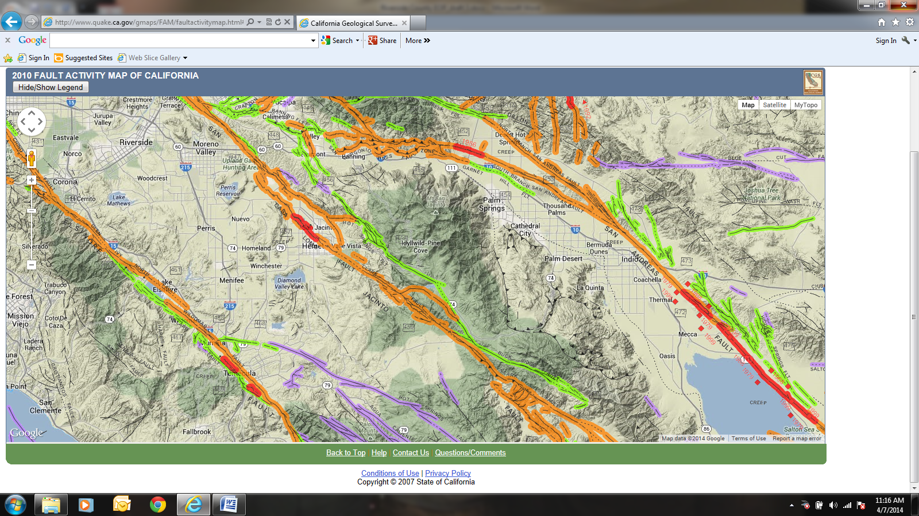

The Alquist-Priolo Earthquake Fault Zoning Act (1972) and the Seismic Hazards Mapping Act (1990) create "Zones of Required Investigation" to minimize the loss of life and property posed by earthquake-triggered ground failures. Cities and counties affected by the zones regulate development "projects". Sellers of real property within a mapped hazard zone must disclose at the time of sale that the property lies within such a zone. Alquist-Priolo Earthquake Fault Zones have been designated by the California Division of Mines and Geology for the Elsinore, San Jacinto, and San Andreas fault zones in Riverside County.

September 21, 2012 maps were released under the authority of the Alquist-Priolo Earthquake Fault Zoning (AP) Act state law designed to reduce the hazard from surface fault rupture during an earthquake. These maps include the Mecca, Mortmar, Orocopia Canyon, Salton, and Durmid Quandrangles. Earthquake Fault Zones are regulatory zones that encompass surface traces of active faults that have a potential for future surface fault rupture.  There are publications related to geologic seismic hazards located at the following website:

<https://www.usgs.gov/centers/geohazards>

The County of Riverside has zoned fault systems and required similar special studies prior to development. These are referred to as County Fault Zones on Figure S-2 and in the Technical Background Report. Within A-P and County Fault Zones, proposed tracts of four or more dwelling units must investigate the potential for and setback from ground rupture hazards. As there are many active faults in Riverside County, with new fault strands being continually discovered, all proposed structures designed for human occupancy should be required to investigate the potential for and setback from ground rupture. Also of concern are structures that can cause harm if damaged by an earthquake, such as utility, communications, and transportation lifelines. The County regulates most development projects within earthquake fault zones. Before a project can be permitted within an A-P Earthquake Fault Zone, County Fault Zone, or within 150 feet of any other potentially active or active fault mapped in published United States Geological Survey (USGS) or California Division of Mining and Geology (CDMG) reports, a geologic investigation must demonstrate that proposed buildings will not be constructed across active faults.

**Earthquake Mitigation**

Comprehensive hazard mitigation programs that include the identification and mapping of hazards, prudent planning and enforcement of building codes, and expedient retrofitting and rehabilitation of weak structures can significantly reduce the scope of an earthquake disaster. Senate Bill 547 addresses the identification and seismic upgrade of potentially hazardous buildings, including: unreinforced masonry, pre-1971 concrete tilt-ups, soft-stories, mobile homes, and pre-1940 homes.

**Ground Failure**

Ground failure induced by earthquake includes liquefaction, lurching, and differential settlement (sinkholes). Liquefaction occurs during earthquakes when water-saturated soils transform into a liquefied state in areas where the water table is less than 50 feet underground. Portions of Riverside County are susceptible to liquefaction during seismic activity as shown in the figure below. 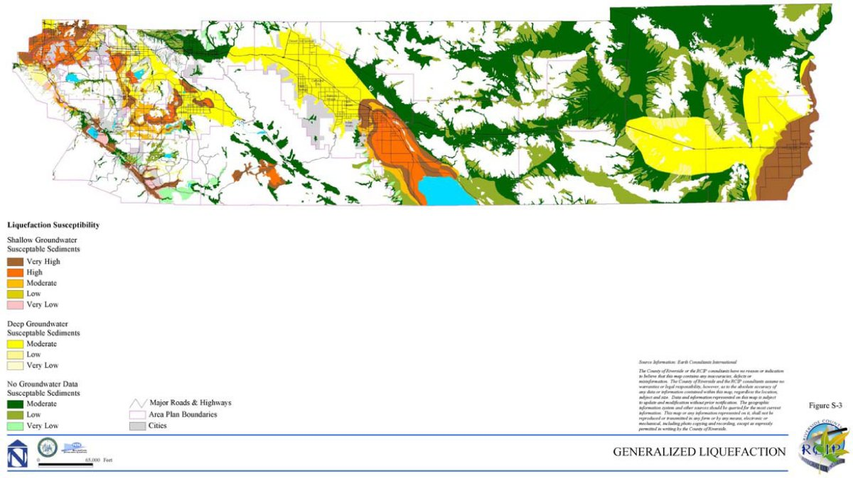

(source: <http://planning.rctlma.org/Portals/0/genplan/content/gp/chapter06.html>)

**Landslides/Debris Flows**

Landslides, or debris flows, are gravity-driven movement of hill slope materials, which can travel at speeds ranging from fractions of an inch per year to tens of miles per hour depending on the slope steepness and water content of the rock/soil mass. Earthquakes can lead to slope failures in mountainous areas throughout the county, especially when the slopes have been denuded from fires in the past. The map below shows landslide susceptibility occurs throughout Riverside County and which areas are less susceptible.

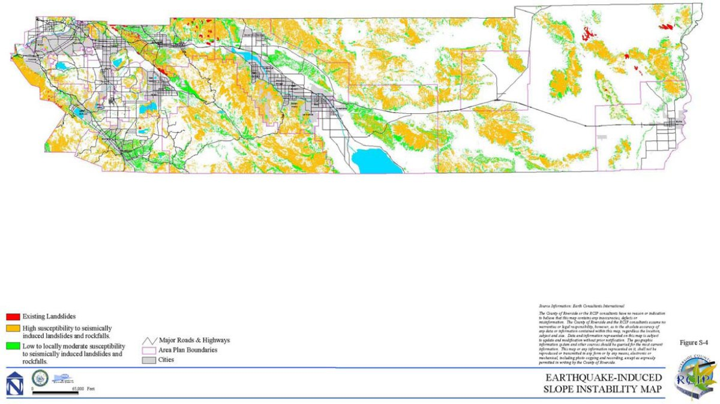

### 

### 2.4.2 Public Health Emergencies

Entity insert information about local hazards and effects if applicable

Public health emergencies include communicable disease outbreaks, such as tuberculosis, hepatitis, and meningitis, as well as public health emergencies resulting from terrorism or natural disasters. The County Health Officer has the authority to proclaim a public health emergency and would lead the efforts throughout the Operational Area to eradicate a public health emergency.

The 20th century saw three global pandemic influenza outbreaks, the most notable of which was the 1918 Spanish influenza pandemic that was responsible for 20-40 million deaths throughout the world. The most recent pandemic, the 2009 H1N1 flu, first identified in Imperial and San Diego counties, killed more than 550 Californians, sent thousands more to hospitals, caused widespread fear and anxiety and the declaration of a public health emergency.

Riverside County EMD may establish Point of Dispensing sites in conjunction with the Riverside University Health System - Public Health, as part of the Strategic National Stockpile (SNS) plan and preparedness. The sites would be established at large gathering facilities such as a community center or public school gym. These sites would allow for the dispensing of medications to a large number of people for prophylaxis of asymptomatic individuals as well as treatment of symptomatic persons. Public health experts are always concerned about the risk of another pandemic where a disease spreads between and amongst species. Depending on the nature of such a disease, if 25% to 35% of the population became ill this would disrupt all aspects of society and severely affect the economy. EMD and RUHS-PH will work closely with local jurisdictions to ensure that:

* Planning efforts are consistent throughout the county;
* Official information will be provided to the jurisdictions in a timely manner;
* Pharmaceutical distribution planning, training and exercising is conducted;
* The organization is SEMS/NIMS compliant.

In Riverside County, both medical (medications, vaccines) and non-medical (school dismissal, isolation and/or quarantine) countermeasures will be implemented as deemed appropriate to mitigate the impact of the emergency on the public's health and safety.

The County, at the direction of the Public Health Officer for Riverside County, will implement the procedures and protocols as recommended**.** To ensure consistent planning efforts, federal, state, and county public health agencies use the World Health Organization (WHO) pandemic phases to guide their planning efforts. These phases may be changed depending on the incident.

## Pandemic Phases

## Chart: Figure 1 describes the overlap risk assessments and the continuum of the global pandemic phases.

Sources: CDC, <https://www.cdc.gov/flu/pandemic-resources/planning-preparedness/global-planning-508.html>

### 2.4.3 Wildland Fires

Entity insert information about local hazards and effects if applicable

Fire is a continuous threat in Riverside County. Wildland fire (wildfire) spreads through vegetative fuels resulting in destruction to property. Wildfires can occur in undeveloped areas and spread to urban areas. The western end of the County is more urban, densely populated, and covered with vegetation that is susceptible to wildfires. The eastern end of the County is primarily desert, with far less population and far less vegetation than the western end of the County. People living near the borders of major forests and brush areas increases the probability of human-caused fires is growing. Other factors related to fire spreading include lightning strikes, Santa Ana winds, homes with a shake roof, and poor control of flammable growth around structures.

In Riverside County, the cities and special districts that are most vulnerable to wildland fires are the cities of Banning, Beaumont, Canyon Lake, Corona, Desert Hot Springs, Eastvale, Hemet, Jurupa Valley, Lake Elsinore, Murrieta, Norco, Perris, Wildomar, and the Fern Valley Water District, Idyllwild Fire Protection District, Idyllwild Water District, Menifee Union School District, Riverside County Office of Education, Riverside Unified School District, and San Jacinto Unified School District.

## 

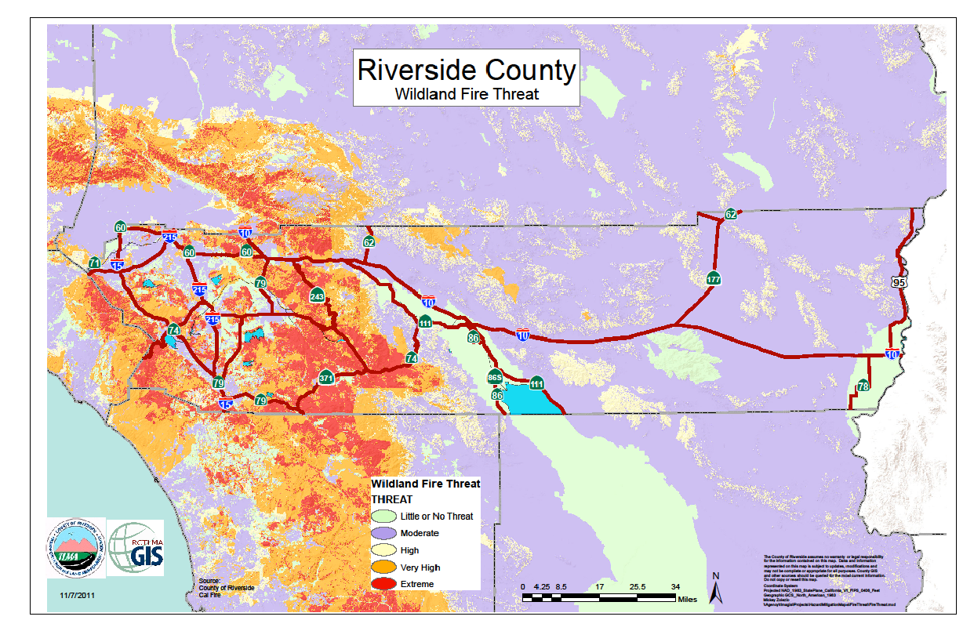**Effects of Wildland Fires**

Fires result in death, injury, economic loss, environmental loss, and significant public investment in firefighting efforts. Woodlands and other natural vegetation can be destroyed resulting in a loss of wildlife habitat, scenic quality and recreational resources. Soil erosion, sedimentation of fisheries and reservoirs, and downstream flooding can also result.

Wildfires often result in power outages. These outages can affect an extensive geographic area. Critical facilities in the line of fire are of particular concern.

There are 15 fire stations that are potentially at risk from wildland fires. In the Idyllwild area, the San Jacinto Mountains are heavily forested and a high hazard area. There are fire stations and schools in high danger areas that cannot be relocated.

Wildfires lead to flooding and erosion. If heavy rains follow a major fire, flash floods, erosion, landslides and mudflows can occur.

### 2.4.4 Electrical Failure and Utility Outages

Entity insert information about local hazards and effects if applicable

A utility failure of extended duration may become a major emergency. Such might be the case in an extended power outage, a disruption in natural gas delivery, or a loss of water supply. A short duration event involving a widespread loss of telephone service may also rise to the level of a major emergency if it involves the public's ability to access the 9-1-1 system. Depending on the type and extent of disruption and other conditions, such as weather, a utility failure can have a broad range of impacts. Persons with access and functional needs are at highest risk from utility disruptions, the whole community in the county would be significantly impacted by a widespread interruption of government, business, and private services.

It is important to recognize that different types of outages are possible so that plans may be made to handle them effectively. Electric power disruptions can be generally grouped into two categories: intentional and unintentional. Intentional disruptions include planned service for maintenance or upgrading. Unintentional disruptions can be caused by an accident; malfunction or equipment failure and/or equipment overload or reduced capability; storms or weather related causes; wildfire that damages transmission lines; or intentional damage, including terrorism.

Utility failures of significant proportion typically arise from other hazard events such as floods or earthquakes, but may occur as standalone events. Immediate objectives would focus on repairs necessary to restore power to areas of greatest need. All critical facilities would require standby generating equipment and emergency fuel supplies.

### 2.4.5 Flooding

Entity insert information about local hazards and effects if applicable

Flooding is a frequent natural hazard impacting Riverside County. Floods are generally classed as either slow-rise or flash floods. Slow-rise floods may be preceded by a warning time lasting from hours to days, or possibly weeks. Evacuation and sandbagging for a slow rise flood may lessen flood-related damage. Flash floods are characterized by extremely short warning times. Regardless of the type of flood, the cause is often the result of excessive rainfall either in the flood area or upstream reach. Floods may also occur from a dam failure. Flash flooding is a common problem in the Coachella Valley and the easterly portions of the county.

Flood effects on agriculture can be devastating, damaging crops, livestock, and dairy stock. In addition to the obvious impacts on animals and crops, flooding can have deleterious effects on soil and the ability to resume the agricultural activities affected once the flood waters recede.

Landslides caused by heavy precipitation send mudslides gushing down rain-sodden slopes. Most mudslides are localized in small gullies, threatening only those buildings in their direct path. They can burst out of the soil on almost any rain-saturated hill when rainfall is heavy enough.

Riverside County has several major river systems, dams, and reservoirs. Excessive rainfall can also stress these systems causing serious damage to property and potential loss of life. Rivers can overflow their banks, destroying bridges and washing out roads and highways during major flood events.

All cities, communities, unincorporated areas, Tribal lands, and special districts within the OA are at risk for flooding. When Riverside County experiences heavy rain or rain over a period of days or weeks, many areas of the County experience flooding.

The western portion of Riverside County contains portions of the Santa Ana River, San Jacinto River and Santa Margarita River watersheds near urban centers. The eastern portion of the county is generally a sparsely populated agricultural region that experiences sporadic flooding. Both common winter storm events and summertime monsoonal flows from Mexico’s Pacific Coast can spawn massive rainstorms, general flooding, and flash floods. The Eastern portion of Riverside County contains portions of the Whitewater River and Colorado River watersheds.

FEMA, has identified 100-year flood hazard areas across Riverside County as shown in the map below.

Many essential public facilities and hazardous materials sites are located within the 100 year flood zones of Riverside County County’s General Plan, these included 14 of the County's 39 airports; 4 of 18 hospitals; 47 of 109 police stations, fire stations, and emergency operation centers; 92 of 380 schools; 446 of 1,306 highway bridges; and 695 of 1,978 hazardous materials sites.

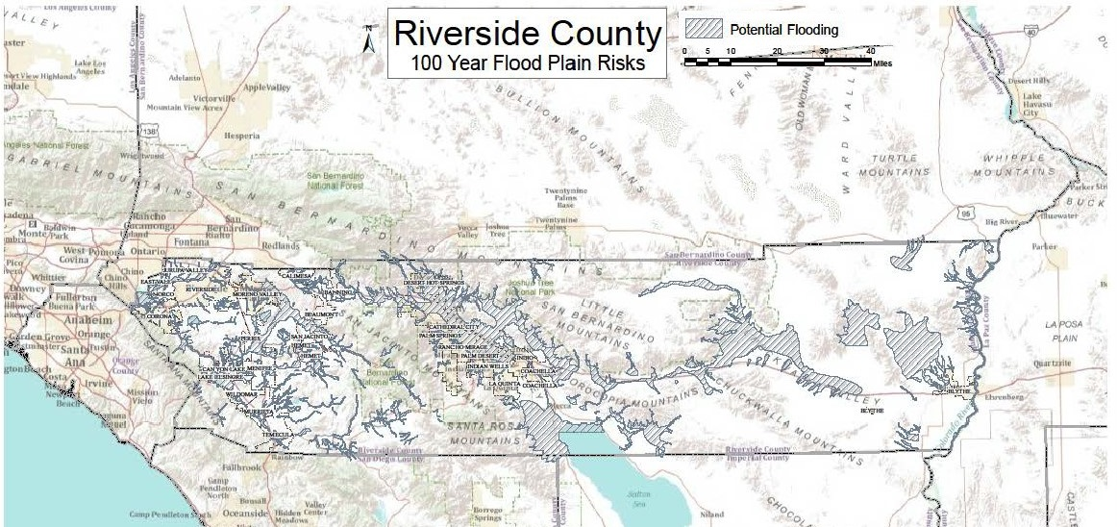

**Dam Failure**

The term “dam failure” encompasses a wide variety of circumstances. Situations that would constitute a dam failure vary widely, from developing problems to a partial or catastrophic collapse of the entire dam. Potential causes of a dam failure are numerous and can be attributed to deficiencies in the original design of the dam, the quality of construction, the maintenance of the dam and operation of the appurtenances while the dam is in operation, and acts of nature including precipitation in excess of the design, flood, and damage from earthquakes. Water over‐topping the dam crest is a common cause of failure in earth dams.

The Riverside County Dam Inundation Risk map is shown below in Figure 4. The California Department of Water Resources lists 45 dams, reservoirs, run-off storage reservoirs, canals, or levees in Riverside County. The dams are listed in the Local Hazard Mitigation Plan. Descriptions of the dams and their inundation impact on the County are outlined in the Dam Inundation Impact Plan, maintained by the County of Riverside Emergency Management Department.

Riverside County is a participant in the National Flood Insurance Program (NFIP) which enables property owners to purchase insurance protection against losses from flooding. Participation in the NFIP required that Riverside County adopt and enforce a floodplain management ordinance to reduce flood risks to new construction in Special Flood Hazard Areas (SFHA). New construction located within a SFHA typically includes minimum elevation requirements, flood resistant construction below the base flood elevation, venting of storage areas or under-floor spaces, and protection of utilities.

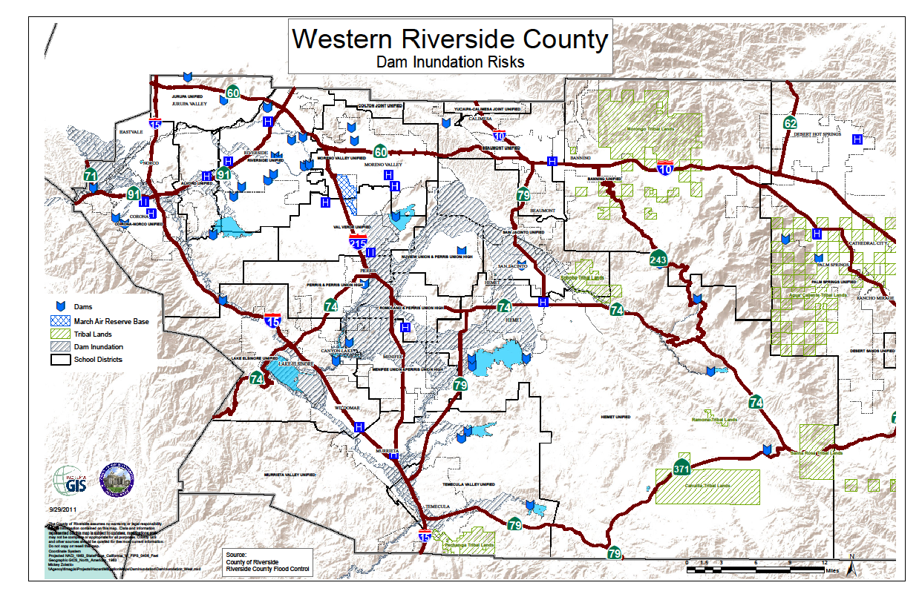

### ARkStorm

The U.S. Geological Survey, Multi Hazards Demonstration Project scientists designed a hypothetical winter storm scenario called ARkStorm (AR for Atmospheric River and k for 1,000 years) that would strike the U.S. West Coast and be similar to the intense California winter storms of 1861 and 1862 that left the central valley of California impassible. The storm would produce precipitation that exceeds levels only experienced once every 500 to 1,000 years.

The scenario predicts extensive flooding, hurricane force winds, landslides, and damage to roads, highways, and homes would occur. Property damage would exceed $300 billion, mostly from flooding. Agricultural losses and other costs to repair lifelines, and repair damage from landslides, would cost another $100 billion. Lifelines refers to power, water, sewer, and natural gas infrastructure damage that may take weeks or months to restore. Flooding evacuation causing business interruption could cause $325 billion in lost revenue in addition to the $400 billion property repair costs, meaning that an ARkStorm could cost up to $725 billion.

The scenario determined the worst flooding would occur along the coastal areas of Orange County, Los Angeles County, San Diego, and the San Francisco Bay area. The Central Valley would experience hypothetical flooding 300 miles long and 20 or more miles wide. The scenario showed Riverside County to be in a high-wind region (75 mph and higher) with potential loss of transmission lines. Property losses in Riverside County are projected from flooding and wind, and also agricultural and livestock damages up to $22 million. The ARkStorm has public policy implications raising serious questions about the ability of existing federal, state, and local disaster planning to handle a disaster of this magnitude.

### 2.4.6 Transportation Hazards

Entity insert information about local hazards and effects if applicable

A mass casualty transportation incident is defined as an incident of air, highway, or rail passenger travel that results in multiple deaths or injuries that require emergency management organization involvement. Transportation incidents can be caused by transportation of hazardous materials, earthquake, hazardous weather, or other hazardous conditions interrupting the flow of transportation and/or public safety.

Traffic density on Interstate 10, 15, and 215, and State Routes (SR) 91 and 60, freeways in the western part of the County is of particular concern. The population and economic growth in this area has caused increased demand on these networks.

Major rail transport lines through Riverside County include Union Pacific and the Burlington Northern Santa Fe (BNSF) Railway Companies. Rails, cars, supporting bridges, overpasses, and electrically-operated switching mechanisms are susceptible to damage. Union Pacific and the BNSF Railway Companies lines enter the Coachella Valley from Imperial County along the eastern shore of the Salton Sea.

There are two major airports in Riverside County: March Air Reserve Base and Palm Springs International Airport. There are also numerous smaller municipal and commercial airports, and private air strips throughout the county.

## 

## Major Transportation Routes

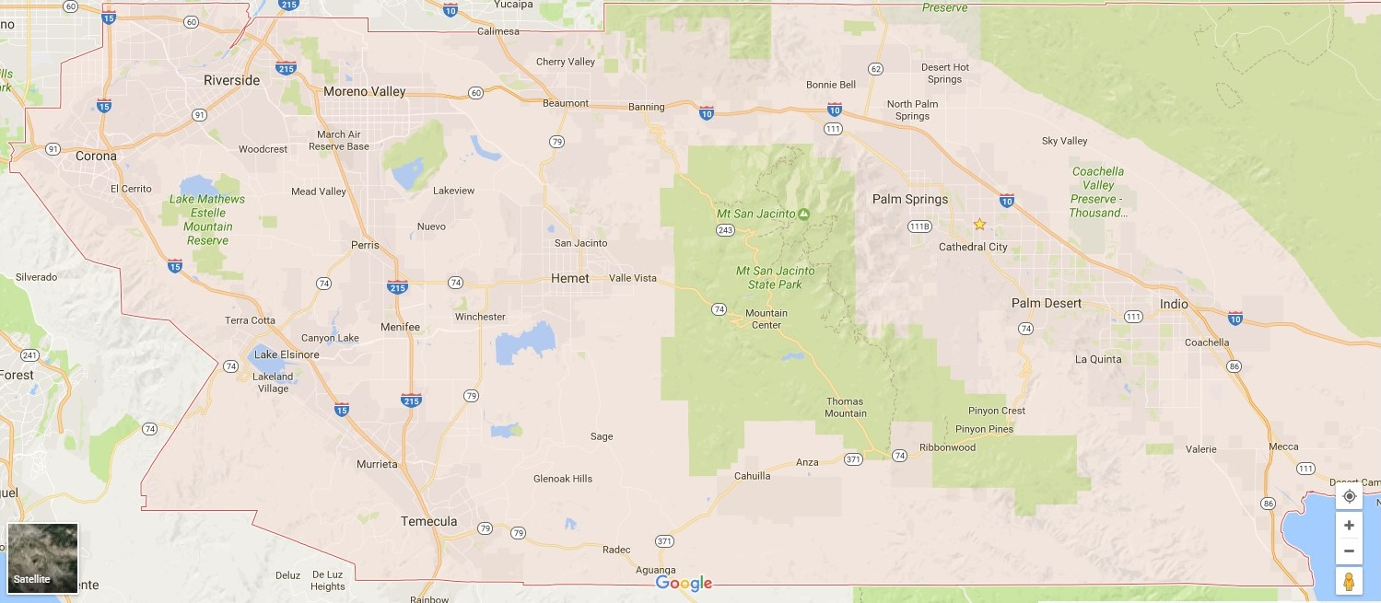

Depending on the location of the incident, the cascading effects of transportation emergencies are generally limited to those of Hazmat incidents as described above. If the incident occurs in the desert when the temperatures are very high life and health may be threatened for citizens in vehicles stopped for several hours. At a minimum there are a lack of conveniences (bathrooms, water, cooling areas).

### 2.4.7 Extreme Weather and Drought

Entity insert information about local hazards and effects if applicable

Riverside County experiences extreme weather and storm conditions regularly, be it extreme heat or cold, high winds, lightning storms, and drought. There have been occasional tornados in Riverside County. Riverside County has a wide range of temperatures, from freezing in some areas during the winter months, to extremely hot temperatures for long periods of time during the summer in the deserts. Extreme weather may cause a variety of damages with most frequent past effects being power and utility outages.

**Extreme Heat & Cold**

Extreme heat can cause heat illness and death. Temperatures are regularly 110 degrees and as high as 122 degrees during the summer months in Riverside County. Freezing temperatures in the mid-20s’ degrees occasionally occur during winter and can cause extensive crop damage.

Riverside County will activate warming or cooling centers as needed during times of excessive weather conditions. The center sites will be designated throughout Riverside County and the cities within the county.

**Droughts**

Droughts differ from typical emergency events such as floods or forest fires, in that they occur slowly over a multiyear period. Drought impacts increase with the length of a drought, as carry-over supplies in reservoirs are depleted and water levels in groundwater basins decline. Droughts can have long-term economic repercussions. Riverside County chronically experiences drought cycles. Drought causes stress on the County’s ability to provide water to the community. In addition, drought conditions cause extensive weakening of trees in forested areas causing them to become highly vulnerable to disease and insect infestation which kills trees creating a severe fire hazard. Drought impact on the County's agricultural industry and home development can be monumental. This is a chronic problem for Riverside County and accounts for significant indirect costs and loss of property.

**Windstorms**

Extreme wind, such as the Santa Ana winds, may cause damage and increased fire activity. Riverside County is in the direct path of the ocean-bound Santa Ana winds. These winds primarily occur between October and February with December having the highest frequency of events. Wind speeds are typically north to east at 35 knots through and below passes and canyons with gusts to 50 knots.

**Tornadoes & Micro-bursts**

Tornadoes are a rare phenomenon in most of California, with most tornado-like activity coming from micro-bursts. In Riverside County both tornadoes and micro-bursts have occurred in the past 10 years in the desert areas causing flooding and power outages.

### 2.4.8 Hazardous Materials Incident

Entity insert information about local hazards and effects if applicable

A hazardous material is any substance that is flammable, combustible, corrosive, poisonous, toxic, explosive or radioactive. Hazardous materials require special care in handling and storage due to the harm they pose to public health, safety and the environment. Many government agencies inspect facilities that use or store hazardous materials to ensure they are in compliance with State and Federal regulations.

Riverside County is susceptible to a hazardous materials release from transportation accidents or spills of stored materials. Additional potential hazardous materials spills are clandestine dumping of toxic or hazardous waste on public or private property. The significance of the problems to the environment, property, or human health is dependent on the type, location and quantity of the material released. Storage facilities are less of a threat than transported materials due to current laws and regulations requiring them to have contingency and evacuation plans. The fire agency having jurisdiction is responsible for ensuring compliance of these facilities and maintaining records of stored quantities of hazardous materials. Additionally, an Emergency Response Plan and Inventory Program is administered by the Riverside County Department of Environmental Health. The County's Hazardous Materials Response Release Plan describes this program in more detail.

The County’s location, with its rail and highway transportation routes, and various industries, has a growing potential for serious hazardous materials incidents. Interstates 10, 15, and 215, and State Routes 60 and 91, are all heavily traveled by trucks. Those trucks carry a wide variety of hazardous materials including, but not limited to, gasoline, rocket fuels, pesticides, and radioactive materials. The railroad lines traveling throughout the County also carry some extremely hazardous cargo. Fortunately, the railroads have a good safety record with regard to the transportation of hazardous materials. Traffic on railroads is not as prevalent as on truck routes in Riverside County, but poses a much greater problem when an accident is involved due to the volumes of hazardous materials being transported.

Besides the immediate effect of hazardous materials incidents on scene, there are also ancillary effects such as the impact on waterways and the evacuation of schools, business districts, and residential areas. All the HazMat response agencies in the county conduct HazMat exercises through the CHOG group (County Hazardous Operations Group).

The Environmental Protection and Oversight Division of the Department of Environmental Health has regulatory control over a number of hazardous materials, land use, and water systems. The County of Riverside, as well as the Cities of Corona and Riverside have been certified by the California Environmental Protection Agency as the Certified Unified Program Agency (CUPA) for implementing a hazardous materials program. The haulers and users of hazardous materials are listed with the County of Riverside Department of Environmental Health and are regulated and monitored under the auspices of the County of Riverside.

### 2.4.9 Insect Infestation

Entity insert information about local hazards and effects if applicable

Insect infestation occurs when an undesirable type of insect inhabits an area in a manner that causes serious harm to crops, livestock, poultry, wild land trees, plants, animals, or humans. Example insects include the Africanized Honey Bee, Bark Beetle, Gold-Spotted Oak Bore Beetle, Citrus Leafminer, Glassy-winged Sharpshooter, Gypsy Moth, Japanese Beetle, various Fruit Flies, Red Imported Fire Ant, Nemotode, Tropical Palm Scale, Asian Citrus Psyllid and Silverleaf Whitefly.

Riverside County has been a part of State disaster proclamation for an insect infestation in the past 20 years with thousands of trees on hundreds of thousands of acres were dying after being weakened by drought and attacked by an infestation of insects. Dead trees over large areas of land can threaten human lives by aiding catastrophic wildfires, and may cause injury and property damage from falling trees.

Insect infestation can also cause the quarantine of agricultural stock, such as grapes and citrus to limit the movement of these crops, which requires inspection and certification of these commodities by the local Agricultural Commissioner prior to movement from the infested area. Riverside County climate is favorable to agriculture all year also makes it possible for insects to reproduce with little natural hindrance to their proliferation.

### 2.4.10 Domestic Security Threats

Entity insert information about local hazards and effects if applicable

Domestic security threats encompass terrorism, civil unrest, and correctional facility incidents. Riverside County and its communities are home to business and government agencies, transportation infrastructure, tourist attractions, natural parks/historic sites, and cultural facilities which are vulnerable to terrorist attack. Terrorism is a continuing threat throughout the world. A variety of political, social, religious, cultural, and economic factors underlie terrorist activities. Terrorists typically target civilians to advance their agenda. The media interest generated by terrorist attacks makes this a high visibility threat.

Domestic Security Threats may cause mass casualties, extensive property damage, fires, flooding, and other ensuing hazards. Domestic Security Threats takes many forms, including:

* Active Shooter Event
* Chemical
* Cyber-terrorism
* Biological
* Radiological
* Nuclear
* Explosive

An Active Shooter is an individual actively engaged in killing or attempting to kill people in a confined and populated area; in most cases, active shooters use firearms(s) and there is no pattern or method to their selection of victims. Active shooter situations are unpredictable and evolve quickly. Typically, the immediate deployment of law enforcement is required to stop the shooting and mitigate harm to victims.

A chemical attack would appear far more likely than either the use of nuclear or biological materials, largely due to the availability of many of the necessary precursor substances needed to construct chemical weapons.

Cyber-terrorism is the use of computer network tools to shut down critical government infrastructures such as energy, transportation, and government operations, or to coerce or intimidate a government or civilian population. The premise of cyber terrorism is that as nations and critical infrastructure became more dependent on computer networks for their operation, new vulnerabilities are created. A form of cyber-terrorism can be carried out by computer viruses and worms.

Biological agents are infectious agent such as a bacteria or virus used to produce illness or death in people, animals, or plants and are extremely difficult to detect.

Radioactive materials could be put in a bomb to spread radiation to cause long lasting health issues and contaminate the target for a long period of time. Although the explosive device is easily recognized, radiation cannot be detected by human senses. There is the possibility that a terrorist organization may acquire the capability to create and detonate a nuclear bomb which would produce fallout affecting an area many times greater than that of the blast itself. This act would cause extreme devastation, long term health effects, and contamination of the blast area, as well as potential radiation in the water and food sources.

Explosive devices account for 86% of Domestic Terrorist incidents and 50% of worldwide terrorist attacks. Most conventional explosives are in the form of package bombs, car or truck bombs, suicide bombers, and backpack type bombs with electronic detonators, which are placed within the public setting to ensure mass casualties. Use of explosive devices remains the weapon of choice for terrorist activity. Incidents generating significant mass casualties make preparedness and the mechanisms for effective response essential.

Related activities include bomb threats which disrupt the normal operations of transit systems, government or corporate facilities. Primary locations likely to be targets include airports, mass transit targets, government facilities, and high population density locations, although so-called soft targets such as schools, local entertainment facilities, sporting events, and concerts are also targets.

These types of emergencies would necessitate detailed contingency planning and preparation of emergency responders to protect their communities. The California State Terrorism Response Plan outlines the authorities and procedures for dealing with a terrorist incident in California. The Federal Bureau of Investigation is designated as the lead federal agency for all terrorist activities within the United States. The FBI coordinates this activity with local law enforcement within the Riverside County OA through the Joint Regional Intelligence Center. The Riverside County Terrorism Response Plan aligns with and supports the State Terrorism Plan. The Riverside County Sheriff’s Department supports the prevention and detection of terrorist activities through the Criminal Intelligence Unit. The Criminal Intelligence Unit has members assigned to the Riverside County Joint Terrorism Task Force.

**Civil Unrest**

Civil Unrest disrupts community affairs and threaten the public safety. Civil Unrest includes riots, mob violence, and any unlawful demonstration resulting in police intervention and arrests. Civil Unrest is generally associated with controversial political, judicial, and/or economic issues and events.

During a Civil Unrest incident that affects Riverside County, there are certain critical facilities within the County that may be more at risk than others. These critical facilities include venues for musical concerts and sporting events, facilities where legal and illegal demonstrations are held, and any other facilities with events that attract large numbers of people. All of these situations create significant traffic congestion and the potential for disruptive behavior. The overall risk of civil unrest in Riverside County may lead to fire, destruction of property, disruption of utilities power, injury to persons, and even loss of life.

**Jails and Prison Incidents**

There are numerous State of California Correctional Institutions and County correctional facilities in Riverside County. Law enforcement is tasked with maintaining order in the facilities and preventing inmates from escaping into the community.

There are numerous jail, detention, incarceration (adult & juvenile), and holding cell facilities in Riverside County. Some of the larger facilities include:

* Bautista Conservation Camp, Hemet
* California Rehabilitation Center, Norco
* Chuckawalla Valley State Prison, Blythe
* East County Detention Center, Indio
* Indio Juvenile Hall
* Ironwood State Prison, Blythe
* Larry D. Smith Correctional Facility, Banning
* Riverside Juvenile Hall
* Robert Presley Detention Center, Riverside
* Southwest Detention Center, Murrieta
* Southwest Juvenile Hall, Murrieta

Even though the following facilities are located in the County of San Bernardino, their proximity to Riverside County may impact the Riverside OA:

* California Institution for Men, Chino
* California Institution for Women, Chino
* Heman J. Stark Youth Correctional Facility, Chino
* Oak Glen Conservation Camp, Yucaipa

Assembly Bill 109 (2011) has shifted state prison populations back into the county jail populations as a way to stop state prison overcrowding.

### 2.4.11 Nuclear Incidents

Radioactive materials are routinely transported in California, whether the materials are for medical or industrial use, as well as wastes that have radioactive components. Many of the radioactive waste shipments come from research and cleanup efforts at national laboratories. Due to strict regulation of nuclear power plants in the United States, significant nuclear power incidents that can cause harm to the public have a low probability of occurrence, and none have occurred in California.

Planning includes an incident involving the San Onofre Nuclear Generating Station (SONGS), which has been shut down since January 2012, after a small radiation leak led to the discovery of unusual damage to hundreds of tubes that carry radioactive water. The plant is shutting down permanently due to problems with steam generators that were installed during an overhaul in 2010, after tests found some generator tubes were badly eroded and could possibly fail and release radiation into the air. Even though the plant may not be operating there may still be a threat due to the presence of the nuclear material in the decommissioning process, which will take up to 60 years to complete.

The possibility exists that a terrorist organization could acquire the capability of creating a small nuclear weapon. A single nuclear detonation in the United States would likely produce fallout affecting an area many times greater than that of the blast itself. A more likely scenario is the possibility that a terrorist will construct a dirty bomb to distribute radiological contaminated materials, which would have less of an effect than a nuclear bomb, but create a great terror effect on the population. A nuclear incident could also be initiated by a transportation emergency, either accidentally or intentionally.

Effects of a nuclear incident could include contaminated water, air, and soil. In the event of a release of radiological materials, whether accidental or intentional, a comprehensive health risk assessment will be conducted and a report of the conclusions for the risk to the general population inside and outside of the affected area. The health risks will be related to an increase in risk for specific cancers for certain subsets of the population and for the people in the most contaminated locations.

Preliminary dose-estimation reports will be developed, typically by the World Health Organization and the United Nations Scientific Committee on the Effects of Atomic Radiation, to indicate whether future health effects due to the radiological exposure may be statistically detectable. Future studies would be conducted to determine if radioactive iodine-131, exceeding safety limits, was detected at key infrastructure providers, such as water plants, to determine the ability to control the spread of radioactive material into the nation's food sources.

The City of Corona has a gamma irradiationfacility that uses Cobalt 60 radiation in the sterilization process to kill microorganisms on a variety of different products, but the gamma process does not create residuals or impart radioactivity in processed products.

### 2.4.12 Toxic Pollution

Exposure to toxic pollution can occur by breathing contaminated air, eating contaminated food products, drinking water contaminated by toxic pollutants, or touching and ingesting contaminated soil. Young children are especially vulnerable because they often ingest objects they place in their mouths or residue from items they have touched.

The County of Riverside General Plan, Air Quality Element addresses toxic pollution. The South Coast Air Quality Management District (AQMD) is the air pollution control agency for all of Orange County and the urban portions of Los Angeles, Riverside and San Bernardino counties, which is the region in the U.S. with the most smog. AQMD is committed to protecting the health of residents, while remaining sensitive to the needs of businesses within the region.

### 2.4.13 Pipeline and Aqueduct Incidents

Pipeline distribution systems transverse Riverside County including water, natural gas, and petroleum products which is common throughout the United States. Increased urbanization is resulting in more people living and working closer to existing gas transmission pipelines that were placed prior to current land use and modern pipeline safety regulations.

Pipe failure can result in loss of life, injury, property damage, and environmental impacts. Causes of and contributors to pipeline failures include construction errors, material defects, internal and external corrosion, operational errors, control system malfunctions, outside force damage, subsidence, and seismic activity. While the degree of damage county-wide for a given rupture may be minimal, there may be significant loss of life and property in the immediate area of the incident, depending on what kind of pipe ruptures and where the rupture occurs.

A major pipeline carrying natural gas parallels Interstate 10 and Highway 60 throughout the County. This pipeline brings gas into Southern California. Petroleum products are stored and distributed at many major areas throughout the County.

Major water conveyance systems consist of the Colorado River Aqueduct operated by

Metropolitan Water District (MWD) of Southern California, the California Aqueduct operated by the State Department of Water Resources (DWR), and water distribution pipelines operated by MWD.

## 2.5 Planning Assumptions

This plan has been developed on the basis of several general assumptions as follows:

* SEMS requires the County Board of Supervisors to establish an OA to include all political subdivisions in the geographic area of the county which consists of the County, Cities, Special Districts, and School Districts. The OA is an intermediate level of the State emergency organization and provides coordination between and communication with the political subdivisions and the State;
* Riverside County government is an OA Member and a separate entity from the Operational Area. Although Riverside County personnel conduct the operations of the Operational Area, the roles and responsibilities of those individuals may be different whether they are acting under the auspices of the OA or Riverside County. For the sake of emergency planning and coordination at the OA Member-level, OA Members may consider the OA and County/OA EOCs as one in the same;
* All OA agencies have developed their emergency plans and/or operating procedures in accordance with this plan and have trained appropriate staff in their contents and use;
* All OA Members and political subdivisions of Riverside County will utilize SEMS and NIMS, as identified in this plan, during response and recovery operations;
* The resources of OA members within Riverside County will be made available to all OA Members to help mitigate the effects of disasters and emergencies in the area;
* Mutual Aid Agreements and Systems exist to support emergency response agencies of the OA. OA Members must exhaust their capabilities before requesting mutual aid assistance;
* The OA will commit the resources of OA Members to a reasonable degree before requesting mutual aid assistance from the regional or state levels.

# Section 3.0 Concept of Operations

## 3.1 Phases of Emergency ManagementImage_13

Emergency management activities during peacetime and national security emergencies are often associated with the four federal emergency management phases indicated below, however, not every disaster necessarily includes all indicated phases. All departments of the County of Riverside have responsibilities in all of the emergency phases.

### 3.1.1 Mitigation Phase

Mitigation efforts occur both before and following disaster events. Post-disaster mitigation is part of the recovery process. Eliminating or reducing the impact of hazards which exist within the county and are a threat to life and property are part of the mitigation efforts. Hazard mitigation includes:

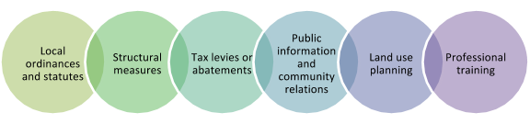

### 3.1.2 Preparedness Phase

The preparedness phase involves activities that are undertaken in advance of an emergency or disaster to develop operational capabilities and effective responses to a disaster including:

• Mitigation activities

• Emergency/disaster planning

• Training and exercises

• Public education on preparedness

For disasters with some warning INCREASED READINESS actions to be accomplished include, but are not necessarily limited to the activities listed below:

Increased Readiness between Warning and Disaster

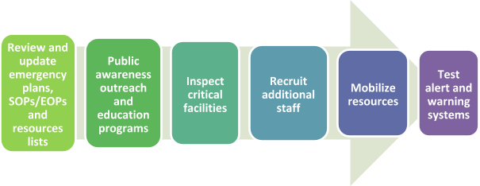

Disaster plans are reviewed to guide disaster response and increase available resources. Planning activities include developing hazard analyses, training response personnel, and improving public information and communications systems. Public awareness and education create resiliency from the bottom up so our communities are less likely to need help if they can sustain themselves. Critical facilities undergo last minute preparations, additional staff and resources are brought in, and warning systems are utilized both to test and to let staff know what efforts are occurring.

##### **3.1.2.1 Management Watch**

Entity insert information if you have a similar on call program

##### During an incident that could adversely impact Riverside County and require a level of response not normally associated with day-to-day operations, a Management Watch may be implemented. The Management Watch requires pre-designated officials to be notified, who will collect and analyze situation information, and refer other matters to the appropriate level for executive decision. County of Riverside Emergency Management Department will monitor current events and notify the CEO that Management Watch is being initiated. At the discretion of the EOC Director, or designee, the following activities may be taken:

* Recall County/OA EOC staff to the office as necessary for the situation
* Make necessary preparations to activate the County/OA EOC
* Establish communications with key County officials to assess the situation
* Establish communications with appropriate Riverside County OA partners, such as cities, Special Districts, schools, and/or Tribal Governments
* Coordinate emergency public information with the appropriate PIO
* Anticipate EOC logistical needs, e.g., food, lodging, supplies, etc.

Management Watch Activation Triggers

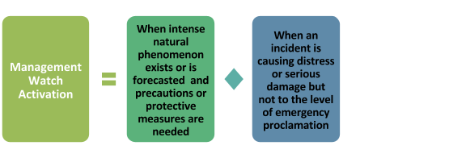

### 3.1.3 Response Phase

The emergency response phase can be further broken down into:

* Pre-Emergency
* Emergency
* Sustained Emergency

**Pre-Emergency Response –** When a disaster is inevitable, actions are precautionary and emphasize protection of life. Typical responses might be:

* Evacuation of threatened populations to safe areas
* Alerting populations and apprising them of safety measures to be implemented
* Notifying your organization leadership and partners
* Identifying and requesting mutual aid
* Requesting an emergency proclamation by local authorities

**Emergency Response –** During this phase, emphasis is placed on saving lives and property, controlling the situation, and minimizing the effects of the disaster. Immediate response is accomplished by Entity Name through timely and effective deployment. One of the following conditions will apply during this phase:

* Situation can be controlled by our staff
* Actions to minimize threats (evacuation for example)
* Outside help is required
* Entity name can provide aid locally or throughout the Operational Area

Entity Name will give priority to the following operations:

* Dissemination of accurate and timely emergency alert and warning to the public
* Situation analysis
* Resource allocation and control
* Evacuation and rescue operations
* Medical care operations
* Mass Care: reception, feeding, and shelter operations
* Access and perimeter control
* Public health operations
* Restoration of vital services and utilities
* Multi-agency coordination
* Prioritization of resource allocations
* Add others if applicable

When local resources are overwhelmed and additional resources are required, requests for mutual aid will be initiated through the County of Riverside Emergency Management Department Duty Officer OR the Riverside OA EOC (if activated). Fire and law enforcement agencies will request mutual aid directly through established mutual aid agreements. If required, the State of California, Governor’s Office of Emergency Services (Cal OES) may be requested by Riverside County to coordinate where resources and supplies can be received, stockpiled, allocated, and dispatched to support operations in affected areas.

Depending on the severity of the emergency, the Riverside OA EOC may be activated to coordinate emergency activities for jurisdictions within the Riverside OA. An emergency may be proclaimed at city and/or county levels. Cal OES may request a gubernatorial proclamation of a State of Emergency. Should a State of Emergency be proclaimed, state agencies will, to the extent possible, respond to requests for assistance. These activities will be coordinated with Cal OES, who may also activate the State Operations Center (SOC) in Sacramento to support regions within the state, state agencies, and other entities in the affected areas, and to ensure the effectiveness of the state's emergency response. The State Southern Regional EOC (REOC) in Los Alamitos will support the Riverside OA EOC. If the Governor requests and receives a Presidential Declaration of an Emergency, or a Major Disaster under Public Law 93-288, he will appoint a State Coordinating Officer (SCO). Federal and State coordinating officers use the options in the strategic plan to make decisions regarding priorities and resources for recovery operations and to coordinate with other State and Federal agencies to leverage available resources and funding.

In the event the Southern REOC is overwhelmed or inoperable, the State and Federal governments form a Unified Coordination Group to consolidate incident-related operational elements of the REOC, SOC, and Incident Management Assistance Team (IMAT) at the Joint Field Office (JFO). Forming the Unified Coordination Group is a decisive concept of operations task that is aimed at achieving effective incident management. The Unified Coordination Group does not assume responsibility for field-level Incident Command activities but provides a structure for the command, control, and coordination of State and Federal resources not yet delivered to the Operational Areas, field-level Incident Command, or end users.

**Sustained Emergency –** In addition to continuing life and property protection operations, mass care, relocation, registration of displaced persons, and damage assessment operations will be initiated.

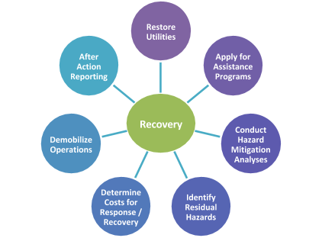

### 3.1.4 Recovery Phase

Recovery operations address the procedures for accessing Federal and state programs available for individual, business, and public assistance following a disaster. This phase also continues long after the disaster is over with the purpose of getting the community back to normal, recovering disaster response funding, and learning from the response to prepare and mitigate for future responses.

## 

## 3.2 Presidential Policy Directive 8- the National Preparedness Goal

The Presidential Policy Directive 8 (September 2011) directed creation of the National Preparedness Goal by stating:

“I hereby direct the development of a national preparedness goal that identifies the core capabilities necessary for preparedness and a national preparedness system to guide activities that will enable the Nation to achieve the goal. The system will allow the Nation to track the progress of our ability to build and improve the capabilities necessary to prevent, protect against, mitigate the effects of, respond to, and recover from those threats that pose the greatest risk to the security of the Nation.”

The National Preparedness Goal which was published in 2011 and again in 2015 is:

“A secure and resilient nation with the capabilities required across the whole community to prevent, protect against, mitigate, respond to, and recover from the threats and hazards that pose the greatest risk.”

The National Preparedness Goal is meant to strengthen the security and resilience of the United States preparing for threats with the greatest risk to the Nation such as terrorism, cyber-attacks, pandemics, and catastrophic natural disasters. National preparedness is a shared responsibility between governments, the private and nonprofit sectors, and individual citizens. Key elements of the National Preparedness Goal include:

* 5 Mission Areas (prevention, protection, mitigation, response, recovery)
* 32 Core Capabilities
* Strategic National Risk Assessment Scenarios
* Concept of the “whole community”

## 3.3 National Incident Management System (NIMS)

Homeland Security Presidential Directive-5 (HSPD-5) established the National Incident Management System (NIMS), integrating best practices into a consistent, flexible and adjustable nationwide approach for emergency management. Using NIMS, Federal, State, local and tribal governments, and private sector and non-governmental organizations work together to prepare for, respond to, and recover from domestic incidents, regardless of cause, size or complexity. Federal and State government agencies are required to use NIMS, while local government agencies and special districts must use NIMS in order to be eligible for federal funding for emergency and disaster preparedness activities.

## 3.4 Standardized Emergency Management System (SEMS)

SEMS is required by the California Emergency Services Act (Government Code Section 8607(a)) for managing multiagency and multijurisdictional responses to emergencies in California. The system unifies all elements of California’s emergency management community into a single integrated system and standardizes key elements. SEMS incorporates the use of the Incident Command System, California Disaster and Civil Defense Master Mutual Aid Agreement, the Operational Area concept and multiagency or inter-agency coordination. State agencies are required to use SEMS and local government entities must use SEMS in order to be eligible for any reimbursement of response-related costs under the state’s disaster assistance programs.

What sets SEMS apart from ICS is that ICS applies to field operations and SEMS originated at the state level where coordinating multi-agency resources and working together in a coordinated effort for sharing of critical resources and the prioritization of incidents. Unified command is what allows multiple agencies with responsibility for an incident, either geographical or functional, to manage an incident by establishing a common set of incident objectives and strategies. This is accomplished without losing or abdicating agency authority, autonomy, responsibility, or accountability.

## 3.5 Incident Command System (ICS)

The Incident Command System (ICS) is a standardized, on-scene, all-hazards incident management approach that:

* Allows for the integration of facilities, equipment, personnel, procedures, and communications operating within a common organizational structure
* Enables a coordinated response among various jurisdictions and functional agencies, both public and private
* Establishes common processes for planning and managing resources

ICS is used by all levels of government—Federal, State, tribal, and local—as well as by many nongovernmental organizations and the private sector. ICS is also applicable across disciplines. It is structured to facilitate activities in five major functional areas: Command, Operations, Planning/Intelligence, Logistics, and Finance/Administration. All of the functional areas may or may not be used depending on the needs of the incident.

## 3.6 SEMS Organizational Levels

Fully activated, SEMS consists of five organizational levels: field response, local government, operational areas, Cal OES Mutual Aid Regions, and State government.

### 3.6.1 Field Response Level

The field response level is where emergency response personnel and resources, under the command of an appropriate authority, carry out tactical decisions and activities in direct response to an incident or threat. The County of Riverside Sheriff’s Department, County of Riverside Emergency Management Department, and police and fire departments of the incorporated cities within the OA serve at the field response level. SEMS regulations require the use of ICS at the field level of a multi-agency or multi-jurisdictional incident. There are five major management functions in ICS:

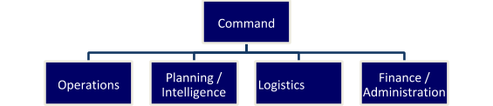

Requests for any resources or support that cannot be filled at the field level are requested through a Department Operations Center (DOC) or the City EOC and/or the County/OA EOC.

### 3.6.2 Local Government Level

A local government is one of the five levels of SEMS. The basic role of a local government is to manage and coordinate the overall emergency response and recovery activities within its jurisdiction. A local government under SEMS is defined as a city, county, city and county, school district, or special district.

Entity insert information if applicable

The County of Riverside Emergency Management Department, has the lead responsibility for SEMS planning within the County of Riverside organization. This involves:

* Communicating information within Riverside County on SEMS requirements and guidelines
* Coordinating SEMS development among departments and agencies
* Identification of all departments and agencies involved in field level response
* Identification of departments and agencies with DOCs
* Coordinating with other local governments, the operational area and volunteer and private agencies on development of SEMS
* Ensuring SEMS is incorporated into Riverside County Emergency Operations Plan and procedures
* Ensuring SEMS is incorporated into Riverside County emergency ordinances, agreements, memorandum of understandings, etc.
* Identification of special districts that operate or provide services within the boundaries of Riverside County. The emergency role of these special districts should be determined and provisions made for coordination during emergencies
* Identification of local volunteer and private agencies that have an emergency response role. Contacts should be made to develop arrangements for coordination in emergencies

### 

### 

### 3.6.3 Operational Area Level

The operational area is defined in the Emergency Services Act as an intermediate level of the state's emergency services organization consisting of a county and all political subdivisions within the county area. Political subdivisions include cities and special districts. There are 58 Operational Areas within the State representing each geographic county. The Riverside Operational Area has an agreement in place that defines roles and responsibilities, as well as jurisdictional authority in an emergency. The Riverside OA is comprised of all local government agencies within the boundaries of Riverside County, which includes all County of Riverside departments and agencies, all incorporated cities, Tribal Governments, and numerous school districts and special districts.

The operational area is responsible for:

* Managing and coordinating information, resources and priorities among local governments within the Riverside OA
* Serving as the coordination and communication link between the local governments within the operational area and the regional level
* Using multi-agency or inter-agency coordination to facilitate decisions for overall operational area level emergency response activities

The County of Riverside Emergency Management Department is the lead agency for the Riverside OA. All local, state and federal governments should cooperate in organizing an effective operational area, but the operational area authority and responsibility is not affected by the nonparticipation of any local government.

Activation of the OA EOC during a State of Emergency or a Local Emergency is required by SEMS regulations under the following conditions:

* A local government within the operational area has activated its EOC and requested activation of the OA EOC to support their emergency operations
* Two or more cities within the operational area have proclaimed a local emergency
* The county and one or more cities have proclaimed a local emergency
* A city, city and county, or county has requested a governor's proclamation of a state of emergency, as defined in the Government Code Section 8558(b)
* A state of emergency is proclaimed by the governor for the county or two or more cities within the operational area
* The OA is requesting resources from outside its boundaries. This does not include resources used in normal day-to-day operations that are obtained through existing mutual aid agreements
* The OA has received resource requests from outside its boundaries. This does not include resources used in normal day-to-day operations which are obtained through existing mutual aid agreements.

Riverside County Operational Area is responsible for coordinating with local governments and the field response level, and for providing mutual aid within their capabilities. Riverside County will comply with SEMS regulations in order to be eligible for state funding of response-related personnel costs and will:

* Use SEMS when a local emergency is declared or proclaimed, or the local government EOC is activated
* Establish coordination and communications with Incident Commander(s) either through DOCs to the EOC or directly to the EOC
* Use existing mutual aid systems for coordinating fire and law enforcement resources;
* Establish coordination and communications between City and Special District EOCs when activated, the Riverside OA EOC, and any state or local emergency response agency having jurisdiction at an incident within the county's boundaries
* Use multi-agency or inter-agency coordination to facilitate decisions for overall local government level emergency response activities

##### **Operational Area Planning Committee**

The County of Riverside Emergency Services Ordinance 533, Section 2.1, establishes the Operational Area Planning Committee (OAPC) by the Board of Supervisors. The OAPC has the responsibility to oversee the emergency management activities of the Riverside OA. Membership in the committee consists of representatives from certain designated county departments, all cities within Riverside County, and all special districts who have signed the OA Agreement. The OAPC has a set of by-laws governing membership, voting, and grant review and funding policies.

### 3.6.4 Regional Level

The regional level manages and coordinates information and resources among operational areas. Cal OES has divided California into three Administrative Regions – Inland, Coastal and Southern – which are further divided into six mutual aid regions. Riverside County is in the Southern Administrative Region, and in Mutual Aid Region VI, which includes the counties of San Diego, Imperial, Riverside, San Bernardino, Inyo and Riverside. Region VI is managed through the Regional Emergency Operations Center (REOC) at the Cal OES Southern Region Office, 4671 Liberty Avenue, Building 283, Los Alamitos, CA. The REOC is managed and staffed by Cal OES personnel.

## Cal OES Mutual Aid and Administrative Regions

### Image_27Image_7

### 3.6.5 State Level

In response to the emergency needs and requests from local governments and operational areas, the state level manages state resources and coordinates mutual aid among the mutual aid regions and between the regional and state levels. The state level also serves as the coordination and communication link between the state and the federal disaster response system. The State Cal OES office is located at 3650 Schriever Avenue, Mather, CA 95655.

### 3.6.6 Federal Level

The Department of Homeland Security has designated the Federal Emergency Management Agency (FEMA) to serve as the main federal government contact during disasters and national security emergencies. In a disaster, different federal agencies may be involved in the response and recovery operations. Federal disaster assistance is organized under the concept of Emergency Support Functions as defined in the National Response Framework. All contact with FEMA and other federal agencies is made through the Operational Areas to the State during the response phase. During the recovery phase, cities, or special district may have direct contact with FEMA and other federal agencies. The FEMA Region IX Office is located at 1111 Broadway, Suite 1200  
Oakland, CA 94607.

## 3.7 SEMS Organization

SEMS regulations require local governments to provide for the five management functions as the basis for structuring the EOC organization:

**Management:** Responsible for overall emergency policy and coordination through the joint efforts of governmental agencies and private organizations.

**Operations:** Responsible for coordinating all jurisdictional operations in support of the emergency response through implementation of the local government's EOC Action Plan.

**Planning/Intelligence:** Responsible for collecting, evaluating, and disseminating information; developing the EOC Action Plan and After-Action Report; and maintaining documentation.

**Logistics:** Responsible for providing facilities, services, personnel, equipment, and materials.

**Finance/Administration:** Responsible for financial activities and other administrative aspects.

##### **3.7.1 EOC Activation Levels**

The following tables represent example incidents of increasing severity that may lead to an OA EOC activation. There are many other types of incidents that could also require activation of the EOC.

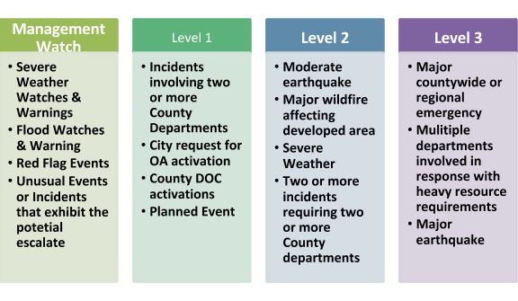

## 3.8 Field Level Interface with the EOC

The concepts, principles and organizational structure of the ICS will be used in managing field operations. The size, complexity, hazard environment, and objectives of the situation will determine the ICS organizational size and the support that will be required to support field activities. The incident will be managed by objectives to be achieved and those objectives are developed through the use of the action planning process.

Typically, an Incident Commander (IC) will communicate with the OA EOC, either via the DOC or directly, as to the situation and resource status. Members of the IC Command and General Staff will communicate with their counterparts in the EOC using the same communications methods. Some members of the EOC Command or General Staff may be asked to attend briefings or planning meetings at an Incident Command Post.

### 3.8.1 Field/EOC Communications and Coordination

Typically, field to EOC communications will occur at the Command and General Staff levels or, if they are established, field units will communicate with a Department Operations Center (DOC) who will, in turn, relay the information to the appropriate section/function in the Riverside OA EOC.

The County/OA EOC will communicate situation and resource status information to the Southern REOC via appropriate means.

### 3.8.2 Field/EOC Direction and Control Interface

The Director of Emergency Services, or designee, will establish jurisdictional objectives and priorities and communicate those to everyone in the organization through the EOC Action Plan. The EOC Action Plan does not direct or control field units but supports their activities. Incident Commander(s) will ensure incident objectives and priorities are consistent with those policies and guidelines established at the county level by the Director of Emergency Services, or designee.

It is the responsibility of Incident Commanders to communicate critical information to the Director of Emergency Services, or designee, in a timely manner.

### 3.8.3 Field/EOC Coordination with Department Operations Centers (DOCs)

If a department within the County establishes a DOC to coordinate and support their departmental field activities, its location, time of establishment and staffing information will be communicated to the Riverside OA EOC. All communications with the field units of that department will be directed to the DOC who will then relay situation and resource information to the Riverside OA EOC. DOCs act as an intermediate communications and coordination link between field units and the Riverside OA EOC.

## 3.9 EOC Action Plans

At local, operational area, regional and state levels, the use of EOC action plans provide designated personnel with knowledge of the objectives to be achieved and the steps required for achievement. Action plans not only provide direction, but they also serve to provide a basis for measuring achievement of objectives and overall system performance.

Action planning is an important management tool that involves:

* A process for identifying priorities and objectives for response or recovery efforts

Documentation of the priorities, objectives, tasks, and personnel assignments

The action planning process should involve the Management Staff and General Staff along with other EOC elements, special district representatives, and other agency representatives as appropriate. The Planning/Intelligence Section is normally responsible for development of the action plan and for facilitation of action planning meetings.

Action plans are developed for a specified operational period that may range from a few hours to 24 hours. The operational period is determined by first establishing a set of priority actions that need to be performed. A reasonable time frame is then established for accomplishing those actions. The action plans need not be complex, but should be sufficiently detailed to guide EOC elements in implementing the priority actions.

## 3.10 After Action/Corrective Action Reports

[SEMS](http://cms.calema.ca.gov/WorkArea/linkit.aspx?LinkIdentifier=id&ItemID=426)  makes it a requirement to complete and transmit an after action report to Cal OES within 90 days of the close of the incident period.

The [Emergency Services Act, Section 8607 (f)](http://cms.calema.ca.gov/WorkArea/linkit.aspx?LinkIdentifier=id&ItemID=428) mandates that the County in cooperation with involved state and local agencies complete an after action report within 120 days after each declared disaster.

An After Action/Corrective Action Report serves the following important functions:

* Provides a source for documenting response and early recovery activities
* Identifies problems and successes during emergency operations
* Analyzes the effectiveness of the different components of SEMS
* Plans corrective action for implementing recommended improvements to existing emergency response efforts

The County of Riverside Emergency Management Department will be responsible for the development of the After Action Report with input from other departments as needed.

## 3.11 Coordination with Emergency Response Levels

### 3.11.1 Coordination with Field Response Level

Coordination among SEMS levels is clearly necessary for effective emergency response. In a major emergency, Riverside OA EOC may be activated to coordinate the overall response while the ICS is used by field responders. Incident Commanders may report pertinent information to DOCs, which in turn will report and coordinate with the EOC. When the Riverside OA EOC is directly supporting Incident Command teams, the EOC is operating in a centralized coordination and support mode.

### 3.11.2 Coordination within the Riverside Operational Area

Coordination and communications should be established between activated local government EOCs and the OA. The communications link may be through the radio system, telephone, fax, email, or amateur radio to ensure notifications, information sharing, and reporting are completed.

### 3.11.3 Coordination with Special Districts

A special district may serve several communities and county unincorporated areas. Some special districts serve multiple jurisdictions. In an emergency situation, the special district may wish to provide a liaison representative to the Riverside OA EOC to facilitate coordination and communication with the various entities it serves, through appropriate mode of communications.

### 3.11.4 Coordination with Volunteer and Private Sector Agencies

Riverside OA EOC will establish communication with private and volunteer agencies that assist the county during emergencies, e.g., American Red Cross, Volunteers Active in Disasters (VOAD), faith based organizations, and community-based organizations. These agencies may assign a representative to the Riverside OA EOC as an Agency Representative. Some agencies may have several personnel participating in functional elements in the Riverside OA EOC, e.g., Red Cross personnel may be part of the staffing for the Care and Shelter Unit of the Riverside OA EOC.

Agencies that have countywide response roles and cannot respond to numerous city EOC’s should be represented within the Riverside OA EOC. Coordination with volunteer and private agencies that do not have representatives at an EOC may be accomplished through telecommunications, liaison with community councils that represent several agencies, or involvement of agencies in special multi-agency groups on specific issues.

## 3.12 Statewide Emergency Management

Governments at all levels must work together effectively, along with the private sector, business and industry, community based organizations and volunteers, to meet the challenges posed by a disaster.

All resources available within the State that may be applied in disaster response and recovery phases, together with the private sector, are collectively referred to as the California Emergency Organization. During a state of war emergency, a state of emergency, or a local emergency, Cal OES will coordinate the emergency activities of all State agencies (California Emergency Services Act, §8587).

Emergency mutual aid response and recovery activities are generally conducted at the request and under the direction of the affected local government. Some emergency responses are led by designated State agencies that will be assigned authority at those emergencies or disasters.

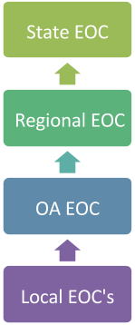Resource requests for response and recovery originate at the lowest level of government and are progressively forwarded to the next level until filled. When support requirements cannot be met with State resources, the State may request assistance from federal agencies having statutory authority to provide assistance in the absence of presidential declarations. The State may also request a Presidential Declaration of an Emergency or Major Disaster under the provisions of the Robert T. Stafford Disaster Relief and Emergency Assistance Act, Public Law 93288 as amended.

### 

### 3.12.1 California Master Mutual Aid Agreement

California's emergency assistance is based on a statewide mutual aid system designed to ensure that additional resources are provided to the state’s political subdivisions whenever their own resources are overwhelmed or inadequate. The basis for this system is the *California Disaster and Civil Defense Master Mutual Aid Agreement*, which is entered into by local governments and the State of California. The various departments and agencies within the political subdivisions, municipal corporations, and public agencies agree to assist each other by providing resources during an emergency. The agreement obligates each signatory entity to provide aid to each other during an emergency without expectation of reimbursement. Under specific conditions, federal, and state monies may be appropriated to reimburse public agencies who aid other jurisdictions. If other agreements, memoranda, and contracts are used to provide assistance for consideration, the terms of those documents may affect disaster assistance eligibility and local entities may only be reimbursed if funds are available. This plan promotes the establishment of emergency assistance agreements between public and private sector agencies at all levels.

### 3.12.2 Emergency Management Assistance Compact (EMAC)

California is a signatory to the interstate EMAC; a congressionally ratified organization that provides form, structure, and procedures for rendering emergency assistance between states. Once the governor has declared a state of emergency, Cal OES will assess the needs for the emergency incident. California can then request resources through the EMAC network for assistance provided by other states in the nation. The use of EMAC resolves two of the key issues regarding mutual aid, liability and reimbursement, so that a disaster impacted state can request and receive assistance from other member states quickly and efficiently.

### 3.12.3 Mutual Aid System

The statewide mutual aid system, operating within the framework of the Master Mutual Aid Agreement, allows for the progressive mobilization of resources to and from emergency response agencies, local governments, operational areas, regions, and state with the intent to provide requesting agencies with adequate resources.

The statewide mutual aid system includes several discipline-specific mutual aid systems, such as fire and rescue, law, medical, and public works. The adoption of SEMS and NIMS does not alter these existing systems, but enhances the facilitation of mutual aid through the local government, operational area, regional, and state levels.

Within California, there are several discipline specific mutual aid plans that work in conjunction with the Master Mutual Aid Agreement. These plans derive their authority from the California Emergency Services Act and from the California Disaster and Civil Defense Master Mutual Aid Agreement.

### 3.12.4 Mutual Aid Coordinators

To facilitate mutual aid, discipline-specific mutual aid systems work through designated mutual aid coordinators at the operational area, regional and state levels. The basic role of a mutual aid coordinator is to receive mutual aid requests, coordinate the provision of resources from within the coordinator's geographic area of responsibility and pass on unfilled requests to the next level. Law Enforcement, Fire and Rescue Services, and the Medical Health Operational Coordinator work within existing state mutual aid systems for requests and assignments of mutual aid.

Mutual aid requests that do not fall into one of the discipline-specific mutual aid systems are handled through the emergency services mutual aid system by emergency management staff at the local government, operational area, regional, and state levels. When EOC’s are activated, all discipline-specific mutual aid systems should establish coordination and communications within the respective local, operational area, regional, or state EOC’s.

Mutual aid system representatives at an EOC may be located in various functional elements (sections, branches, groups, or units) or serve as an agency representative, depending on how the EOC is organized and the extent to which it is activated.

## Figure: Discipline Specific Mutual Aid System

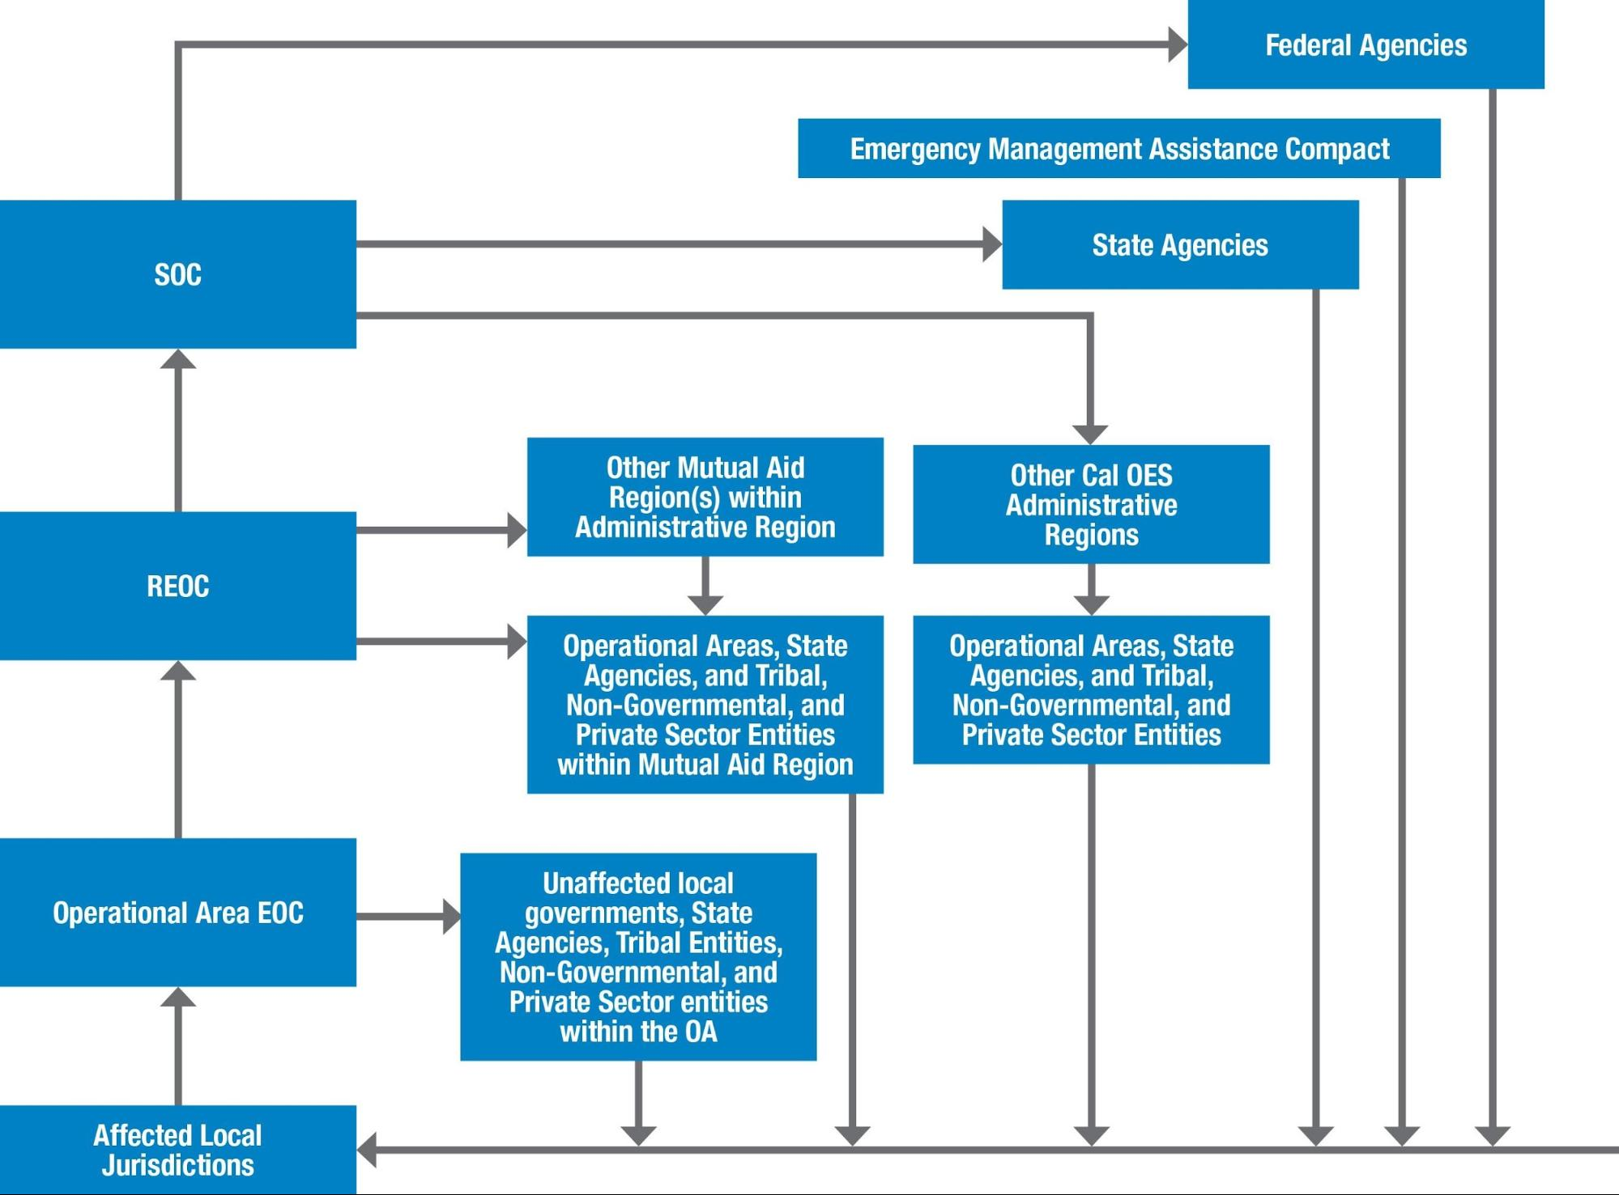

### 3.12.5 Mutual Aid Agreements

Riverside County is a participant in the following mutual aid agreements:

* California Master Mutual Aid Agreement
* California Medical Mutual Aid Agreement
* Region VI Fire and Rescue Operations Plan
* Region VI Law Enforcement Mutual Aid Agreement
* Region VI Public Works Mutual Aid Agreement
* Region VI Medical Services Mutual Aid Agreement
* Emergency Managers Mutual Aid Agreement
* Volunteer and Private Agencies Mutual Aid Agreement
* Riverside Operational Area Agreement

### 3.12.6 Riverside County/OA Mutual Aid Requests

Cities within Riverside County will make mutual aid requests through the Riverside OA EOC. Riverside County will make mutual aid requests through the Cal OES Southern REOC. Requests for Fire and Law Enforcement mutual aid will be made through existing Regional Mutual Aid Coordinators that may be present at the Riverside OA EOC.

## 3.13 Riverside County Emergency Organization

The California Emergency Services Act requires Riverside County to manage and coordinate the overall emergency response and recovery activities within its jurisdiction. The County Director of Emergency Services, per Riverside County Municipal Code 5204, is responsible to impress into service all officers and employees of Riverside County, together with volunteers, groups, and organizations enrolled to aid them during an emergency, to constitute the emergency organization of Riverside County. All departments and agencies will use the ICS for emergency response and provide emergency related information to the Riverside OA EOC. The Emergency Organization chart shows the County departments within the SEMS/NIMS concept.

Figure: Riverside County Emergency Organization

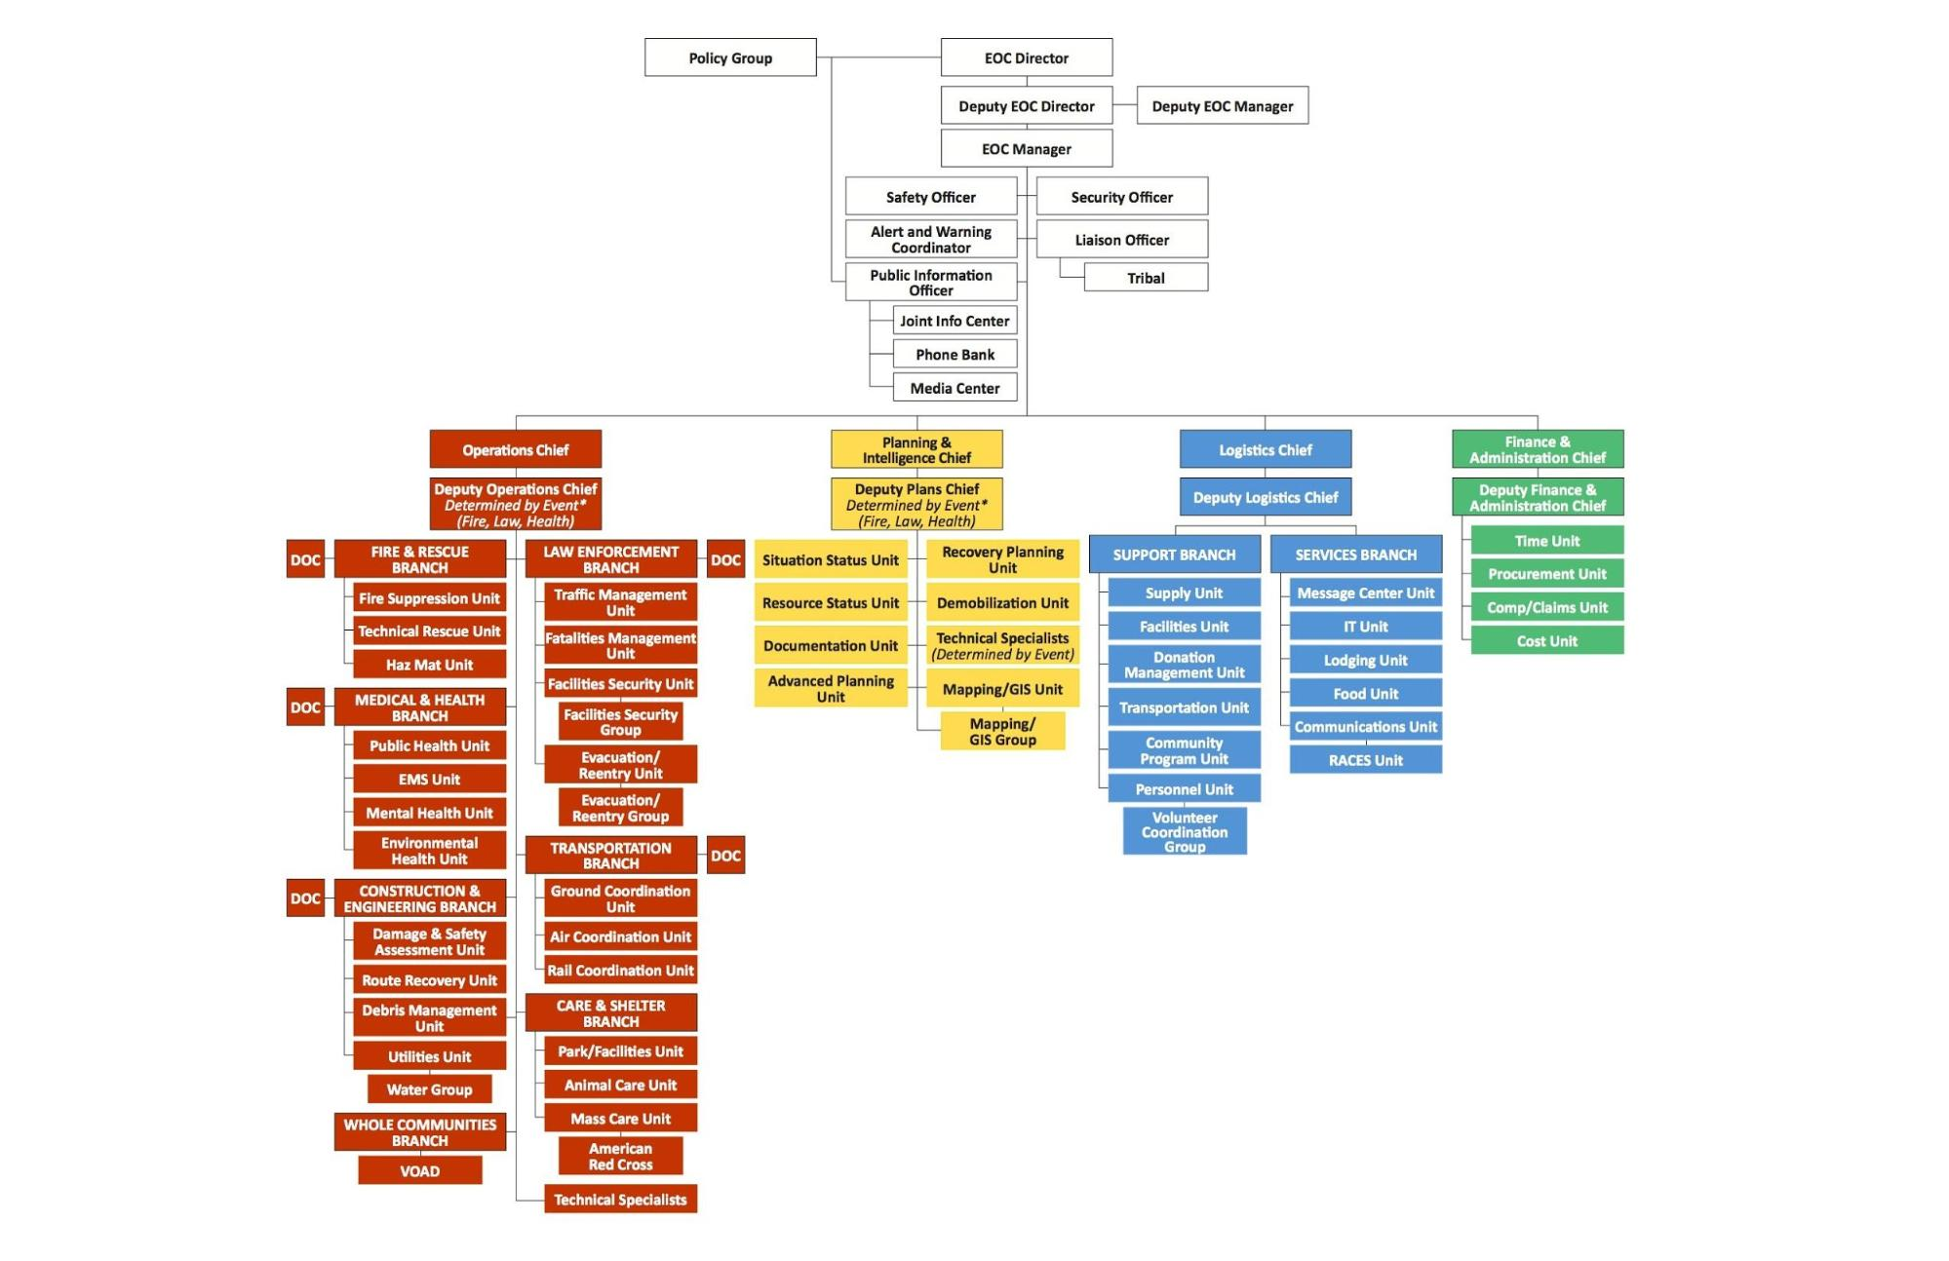

### 3.13.1 Emergency Proclamations

A Local Emergency may be proclaimed by the Board of Supervisors or by the County Director of Emergency Services (Chief Executive Officer) as specified by Riverside County Ordinance 533 or by the County Health Officer, per Health and Safety Code 101080. A Local Emergency proclaimed by the Chief Executive Officer or Health Officer must be ratified by the Board of Supervisors within seven days. The governing body must review the need to continue the proclamation at least every thirty days until the Local Emergency is terminated or may expire. The Local Emergency may be terminated by resolution when conditions warrant. Proclamations are normally made when there is an actual incident, threat of disaster, or extreme peril to the safety of persons and property within the county caused by natural or man-made situations. The proclamation of a Local Emergency provides the governing body with the legal authority to:

* Request that the Governor proclaim a State of Emergency
* Promulgate or suspend orders and regulations necessary to provide for the protection of life and property, including issuing orders or regulations imposing a curfew within designated boundaries
* Exercise full power to provide mutual aid to any affected area in accordance with local ordinances, resolutions, emergency plans, or agreements
* Request state agencies and other jurisdictions to provide mutual aid
* Require the emergency services of any local official or employee
* Requisition necessary personnel and materials from any local department or agency
* Obtain vital supplies and equipment and, if required, immediately commandeer the same for public use
* Impose penalties for violation of lawful orders
* Conduct emergency operations without incurring legal liability for performance or failure of performance (see Article 17 of the Emergency Services Act for privileges/immunities)

### 3.13.2 State of Emergency

A State of Emergency may be proclaimed by the Governor when:

* Conditions of disaster or extreme peril exist which threaten the safety of persons and property within the state caused by natural or man-made incidents
* The Governor is requested to do so by local authorities
* The Governor finds that local authority is inadequate to cope with the emergency
* Mutual aid shall be rendered in accordance with approved emergency plans when the need arises in any county, city and county, or city for outside assistance

When a State of Emergency has been proclaimed:

* The Governor shall, to the extent deemed necessary, have the right to exercise all police power vested in the state by the Constitution and the laws of the State of California within the designated area;
* Jurisdictions may command the aid of citizens as deemed necessary to cope with an emergency
* The Governor may suspend the provisions of orders, rules or regulations of any state agency and any regulatory statute or statute prescribing the procedure for conducting state business
* The Governor may commandeer or make use of any private property or personnel (other than the media) in carrying out the responsibilities of their office
* The Governor may promulgate, issue, and enforce orders and regulations deemed necessary

### 3.13.3 State of War Emergency

Whenever the Governor proclaims a State of War Emergency, or if a State of War Emergency exists, all provisions associated with a State of Emergency apply, additionally:

* All state agencies and political subdivisions are required to comply with the lawful orders and regulations of the Governor which are made or given within the limits of his authority as provided for in the Emergency Services Act.

## 3.14 Continuity of Government

Continuity of Government (COG) is the principle of establishing defined procedures that allow a government to continue its essential operations in case of a catastrophic event and ensure an enduring constitutional government. The essential functions are normal operations not disaster response functions. Continuity of Government is operationalized through the Continuity of Operations Plan which specifies essential functions, alternate facilities, and lines of succession.

### 3.14.1 Alternate Seat of Government

Section 23600 of the California Government Code provides alternate seats of government:

* The Board of Supervisors shall designate alternative county seats, which may be located outside county boundaries
* Real property cannot be purchased for this purpose
* A resolution designating the alternate county seats must be filed with the Secretary of State
* Additional sites may be designated subsequent to the original site designations if circumstances warrant

In the event the primary location is not usable because of emergency conditions, the city of Indio is designated as the alternate seat of government for the county.

* The alternate seat shall be used at the determination of the Board of Supervisors or the County Director of Emergency Services, or designee, when there is no ability to continue with county business from a location within the general jurisdiction of the city due to war or peacetime emergencies.
* If the alternate seat for the county is activated, all business of the county transacted there shall be legal and binding as if transacted at the county seat.
* Two emergency operating centers shall be maintained to meet emergency contingencies, and shall be maintained in accordance with Board Policy H-14.

### 3.14.2 Lines of Succession

The first step in assuring continuity of government is to have personnel who are authorized and prepared to carry out emergency actions for government in the event of a natural, technological, or national security disaster. Article 15, Section 8638 of the Emergency Services Act authorizes governing bodies to designate and appoint three standby officers for each member of the governing body and for the chief executive, if not a member of the governing body. Standby officers may be residents or officers of a political subdivision other than that to which they are appointed.

Notification of any successor changes shall be made through the established chain of command. Article 15, Section 8637 of the Emergency Services Act authorizes political subdivisions to provide for the succession of officers (department heads) having duties related to law and order and/or health and safety.

Article 15, Section 8633 of the Emergency Services Act establishes a method for reconstituting the governing body. It authorizes that should all members, including all standbys, be unavailable, temporary officers shall be appointed as follows:

* By the chairman of the board of the county in which the political subdivision is locate;
* By the chairman of the board of any other county within 150 miles (nearest and most populated down to farthest and least populated)
* By the mayor of any city within 150 miles (nearest and most populated down to farthest and least populated)

Article 15, Section 8642 of the Emergency Services Act authorizes local governing bodies to convene as soon as possible whenever a State of War Emergency, State of Emergency, or Local Emergency exists, and at a place not necessarily within the political subdivision. Article 15, Section 8643 of the Emergency Services Act describes the duties of a governing body during emergencies as follows:

* Ascertain the damage to the jurisdiction and its personnel and property
* Reconstitute itself and any subdivisions
* Perform function in preserving law and order and furnishing local services

**3.14.3 Departmental Lines of Succession**

|  |  |
| --- | --- |
| Function / Department | Title / Position |
| Entity specifics needed… |  |
|  |  |
|  |  |
|  |  |
|  |  |
|  | |
| Should the County Chief Executive Officer be unavailable or unable to serve, the positions listed below, in order, shall act as the County Director of Emergency Services. The individual who serves as acting director shall have the authority and powers of the Director, and will serve until the Director is again able to serve, or until a successor has been appointed by the Board of Supervisors.  1st Alternate: Assistant Chief Executive Officer  2nd Alternate: County Sheriff  3rd Alternate: County Fire Chief  4th Alternate: County Public Health Officer  5th Alternate: Director Transportation and Land Management Agency  6th Alternate: Director Public Social Services | |

### 3.14.3 Vital Record Retention

Vital records include those records that are essential to the rights and interests of individuals, governments, corporations, and other entities such as vital statistics, land and tax records, license registers, articles of incorporation, and historical information. Vital records also include those records essential for emergency response and recovery operations, including utility system maps, emergency supple and equipment locations, emergency operations plan and procedures, and personnel rosters.

The preservation of vital records is critical to the County’s recovery from a catastrophic event. In addition to the information retrieval requirements of response, each response function has a record-keeping component. Although the principal focus of vital records preservation is to support recovery through reimbursement of disaster-related costs, vital records also have a broader and more important function in that they help to describe a reasonably complete compilation of damage, death, physical and mental trauma, and allocation of public and private resources, making it possible to learn from the disaster experience. Vital records for the County are maintained by the County Assessor-Clerk-Recorder’s Office.

These vital records are essential to the re-establishment of normal government functions for Riverside County, serving to protect the rights and interests of government which are encapsulated in the constitutions, charters, statues, ordinances, court records, official proceedings, and financial records of Riverside County. Vital records of Riverside County are routinely stored in the County-Assessor-Clerk-Recorder’s Office.

## 3.15 Training, Documentation and Exercises

Entity insert training information

The appropriate SEMS/NIMS/ICS training will be provided to all public safety, EOC, and first responder personnel. Each county department is responsible to schedule and document emergency management training for their employees that have been designated with an emergency role.

The core ICS training courses have been revised to reflect lessons learned since their release in 2006. The courses of training will be selected from the following list, commensurate with individual and supervisory responsibilities:

* Introduction to SEMS
* IS-700.a: NIMS An Introduction
* IS-800.b: National Response Framework, An Introduction
* IS-100.b: Introduction to Incident Command System, ICS 100
* IS-200.b: ICS for Single Resources and Initial Action Incidents, ICS 200
* ICS-300: Intermediate ICS for Expanding Incidents
* ICS-400: Advanced ICS Command and General Staff—Complex Incidents

The County of Riverside Emergency Management Department is responsible for coordination and scheduling of regular exercises of this plan to train all necessary County staff in the EOC and proper response to disaster situations.

There are additional courses designed to enhance skills development and are geared towards fulfilling SEMS/NIMS credentialing tracks. County departments should document the training provided to emergency response personnel. Copies of SEMS/NIMS training records are maintained by the department as follows:

* An individual training record for each person, kept in their personnel file, or in a separate training record file. The name of the course, instructor, location, and date of the course should be included in the training record.
* Maintenance of the individual training record for as long as the person is employed in a position that involves an emergency response role. Records of personnel involved in an actual emergency are archived for five years after the close of a disaster or indefinitely.
* Documentation of the agency’s SEMS/NIMS training program including copies of the training materials used, such as instructor syllabus, lesson plans, student notebook, exercises and tests.

Exercises, drills, and actual incidents are a means for improving plans and systems through evaluation of the response activities. Exercises also encourage participation from Operational Area jurisdictions for effective coordination of disaster response capabilities. An After Action Report (AAR) will be developed for exercises and actual incidents. In addition, a Corrective Action Plan process will be completed for implementing improvements outlined in AARs. This system is in accordance with the guidance on SEMS/NIMS implementation.

An exercise is a simulation of a series of emergencies for identified hazards affecting the County. During these exercises, emergency response organizations are required to respond as though a real emergency had occurred. If necessary, the public will be made aware of these exercises through normal media communications. Tabletop, Functional, and Full Scale exercises will be conducted utilizing the concepts and principles of the SEMS/NIMS.

County of Riverside Emergency Management Department will inform County departments and Operational Area partners of training and exercise opportunities associated with emergency management. Those with responsibilities under this plan must ensure their personnel partake in training and exercises in order to effectively carry out their disaster responsibilities. An actual EOC activation may take the place of a scheduled exercise.

## 3.16 Requirements of the Americans with Disabilities Act and California Access and Functional Needs Legislation

Access to emergency services shall not be denied on the grounds of race, color, national origin, sex, age, or handicap. To ensure that this goal is met, Title II of the ADA requires State and local governments to make their programs and services accessible to persons with disabilities. This requirement extends not only to physical access at government facilities, programs, and events -- but also to policy changes that governmental entities must make to ensure that all people with disabilities and others with access and functional needs can take part in, and benefit from, the programs and services of State and local governments. In addition, governmental entities must ensure effective communication -- including the provision of necessary auxiliary aids and services -- so that people with disabilities and others with access and functional needs can participate in civic life.

The Americans with Disabilities Act of 1990 (ADA) signed into law on July 26, 1990, by President George H. W. Bush, is a broad civil rights law that prohibits discrimination against people with disabilities and others with access and functional needs, including but not limited to mobility, vision, hearing, cognitive disorders, mental illnesses, and language barriers. In 2008, President George W. Bush signed an updated version of the ADA, which is known as the ADA Amendments Act (ADAAA). The revised law broadens the scope of the definition of what it means to have a disability. These changes went into effect January 1, 2009. These amendments make it easier for individuals whole require whole community support services to seek protection under the law.

Riverside County will make every effort to address the needs of individuals who require whole community support services. Initially, priorities are focused on lifesaving operations, evacuations and stabilization of the incident. Riverside County will take into consideration the needs of individuals such as issues with communications, mobility, and accessibility. Included in the County’s planning efforts for individuals who require whole community support services are:

* TTD/TTY contact and captioned cable alert for the hearing-impaired
* Spanish/English outreach programs, identified language skills of County employees for interpretation
* ADA compliant access to County facilities and Red Cross shelter facilities
* Identified transportation assistance for those requiring physical assistance
* Reverse 911 telephone system for specific geographic areas
* Notification and warning procedures
* Evacuation considerations
* Emergency transportation issues
* Sheltering requirements
* Accessibility to medications, refrigeration and back-up power
* Accessibility for mobility devices or service animals while in transit or at shelters
* Accessibility to emergency information

**Access and Functional Needs Planning Guidance**

Riverside County Operational Area received the following guidance from the California Governor’s Office of Emergency Services (Cal OES), Office of Access and Functional Needs. Assembly Bill 2311 (Brown, Chapter 520, Statutes of 2016), which added California Government Code section 8593.3, requires each county and city to integrate access and functional needs upon the next update to its emergency response plan. Specifically, jurisdictions must address how it will serve the access and functional needs community in:

* Emergency communications;
* Emergency evacuations; and
* Emergency sheltering.

Part of any successful planning effort is to understand the impacted population(s). The legal requirements are set forth in Government Code section 8593.3, and define access and functional needs as individuals who *have*:

* Developmental, intellectual or physical disabilities;
* Chronic conditions or injuries;
* Limited English proficiency or non-English speaking;

Or, individuals who *are*:

* Older adults, children, or pregnant;
* Living in institutional settings;
* Low-income, homeless, and/or transportation disadvantaged; or
* From diverse cultures.

Lessons documented from years of assisting individuals with access and functional needs in disasters show three areas repeatedly identified as needing improvement: communications, evacuation, and sheltering.

**Emergency communications**

During a disaster, effective communication becomes especially critical. As such, information delivered at press conferences by public officials and broadcasted on television during a disaster needs to be effective, understood, consumable, and actionable by the whole community. Effective communication considerations include:

* Sign Language interpreters for individuals who are deaf or hard of hearing;
* Alternative formats for individuals who are blind/low vision; and
* Translation services for persons with limited English proficiency or for non-English speaking individuals.

**Emergency evacuation**

When local evacuations become necessary, considerations for the whole community include:

* Accessible transportation options;
* Medical needs; and
* Keeping individuals connected with their families, personal care providers, essential equipment and technologies, and service animals.

Proper planning is essential to a successful evacuation and includes having agreements and partnerships in place with local public and private accessible transportation providers in order to ensure individuals with disabilities and persons with access and functional needs can evacuate safely during emergencies.

Emergency evacuation plans should be viewed as living documents because communities change and integrating the needs of individuals with access and functional needs is a dynamic process. Emergency managers should work and partner with their local disability and whole community stakeholders to regularly practice, review, revise, and update their plans to reflect changes in technology, personnel, and procedures.

**Sheltering**

Shelters can be stressful environments and may, without proper planning, exacerbate the physical and emotional impacts that survivors with access and functional needs experience during disasters.

Sheltering needs to be inclusive and integrated, not segregated. General population shelters need to be in physically accessible locations and equipped with accessible resources (e.g. bathrooms, cots, showers, etc.) to meet the needs of individuals with access and functional needs in a manner that ensures they can remain with their support systems (e.g. personal care provider, service animal, etc.). Assessing potential sheltering facilities before disasters occur is essential as designated shelters should comply with the requirements of the Americans with Disabilities Act (ADA).

Additional Resources

The Cal OES Office of Access and Functional Needs has made resources available to assist communities as they integrate access and functional needs within their emergency planning. Two such tools are:

**The Cal OES Access and Functional Needs Web Map**

To empower emergency managers to identify the access and functional needs-related assets and resources needed to support the health and independence of survivors, the Cal OES Office of Access and Functional Needs partnered with the Cal OES’ GIS Division to create the [California AFN Web Map](http://calema.maps.arcgis.com/apps/Viewer/index.html?appid=5b9d055d91814f63b7ceca645b6cc75f) – the first-ever searchable, comprehensive, statewide resource for locating AFN-related assets and resources in California.

Using data from the U.S. Census, the web map contains the following information for every county in the State of California:

* *Disability* - Total number of individuals in each county with a disability, listed into four categories: hearing difficulty; vision difficulty; cognitive difficulty; and ambulatory difficulty.
* *Culture* - The ethnicity and primary language(s) spoken at home within each county.
* *Age* - The age (across the life spectrum) of individuals in every county.

The web map outlines where each of the following resources are located:

* *Accessible Hygiene Resources* - Showers, toileting, and hand washing stations that meet Americans with Disabilities Act (ADA) standards.
* *Accessible Transportation* - Organizations providing public transportation services to seniors and individuals with disabilities that meet Americans with Disabilities Act (ADA) standards.
* *American Sign Language Interpreting Services -* Organizations providing interpretation services for individuals who are deaf or hard of hearing.
* *Assistive Technology* - Organizations providing devices, equipment or technology systems, and services for individuals with disabilities.
* *Community Emergency Response Teams (CERT) Programs* - Local programs that educate individuals about disaster preparedness and train them in basic disaster response skills.
* *Independent Living Centers -* Community-based, non-profit organizations designed and operated by individuals with disabilities.
* *Language Translation Services -* Organizations providing written text or interpretation services in a language other than English.
* *Regional Centers* - Non-profit private corporations that contract with the Department of Developmental Services to provide or coordinate services and support for individuals with developmental disabilities.

**The Cal OES Office of Access and Functional Needs Library**

In order to ensure that community leaders, state agencies, advocacy organizations, emergency managers and others have the best and most current access and functional needs-related planning resources available in an easy to access, one-stop-shop central repository, we created the [OAFN Library](http://www.caloes.ca.gov/cal-oes-divisions/access-functional-needs/afn-library). The OAFN Library is a comprehensive clearinghouse for access and functional needs-specific best practices, guidance documents, videos, and more. For additional questions regarding access and functional needs contact the Cal OES Office of Access and Functional needs at: [OAFN@caloes.ca.gov](mailto:OAFN@caloes.ca.gov)

The new Government Code reads:

8593.3. (a) A county, including a city and county, shall, upon the next update to its emergency plan, integrate access and functional needs into its emergency plan by addressing, at a minimum, how the access and functional needs population is served by the following:

(1) Emergency communications, including the integration of interpreters, translators, and assistive technology.

(2) Emergency evacuation, including the identification of transportation resources and resources that are compliant with the federal Americans with Disabilities Act of 1990 (42 U.S.C. Sec. 12101 et seq.) for individuals who are dependent on public transportation.

(3) Emergency sheltering, including ensuring that designated shelters are compliant with the federal Americans with Disabilities Act of 1990 (42 U.S.C. Sec. 12101 et seq.) or can be made compliant through modification and that showers and bathrooms are fully accessible to all occupants.

(b) For purposes of this section, the “access and functional needs population” consists of individuals who have developmental or intellectual disabilities, physical disabilities, chronic conditions, injuries, limited English proficiency or who are non-English speaking, older adults, children, people living in institutionalized settings, or those who are low income, homeless, or transportation disadvantaged, including, but not limited to, those who are dependent on public transit or those who are pregnant.

### 3.16.1 Individuals Requiring Whole Community Support Services

Individuals in need of Whole Community Support Services may include those who have disabilities; who live in institutionalized settings; who are older adults; who are children; who are from diverse cultures; who have limited English proficiency or are non-English speaking; or who are transportation disadvantaged. According to a 2010 study, there are almost 11 million people who require access to Whole Community Support Services in California. The lessons documented from the years of assisting individuals who require whole community support services in disasters show three areas that are repeatedly identified as most important to these individuals: communications (alert, warning, notification), evacuation (transportation), and sheltering.

## 3.17 Animal Care Considerations

The PETS Act (Pets Evacuation and Transportation Standards Act of 2006) directs that state and local emergency preparedness plans address the needs of people with pets and service animals after a major disaster, including the rescue, care and sheltering of animals. The PETS Act amends the Stafford Act, and requires evacuation plans to take into account the needs of individuals with household pets and service animals, prior to, during, and after a major disaster or emergency. Riverside County has an Animal Control department that will lead the effort to comply with the PETS Act.

In conjunction with the Department of Animal Services, Animal Control officers and shelter attendants will provide for the coordination of evacuation and sheltering of household and service pets in the event of a disaster.

|  |  |
| --- | --- |
| **Shelter Name** | **Areas Served** |
| Animal Friends of the Valleys | Canyon Lake, City of Lake Elsinore, City of Temecula, City of Murrieta |
| Beaumont Animal Control | City of Beaumont, Banning, Calimesa |
| Corona Animal Shelter | City of Corona |
| Moreno Valley Animal Shelter | City of Moreno Valley |
| Norco Animal Shelter | City of Norco |
| Palm Springs Animal Shelter | City of Palm Springs |
| Perris Animal Control | City of Perris (Animals go to Moreno Valley shelter) |
| Ramona Humane Society | Hemet, Homeland, Nuevo, Romoland, San Jacinto, Sun City, Winchester |
| Rancho Cucamonga Animal Shelter | City of Rancho Cucamonga |
| Rancho Mirage Animal Control | City of Rancho Mirage (Animals go to the Coachella Valley Animal Campus) |
| Riverside County Animal Shelter | Blythe |
| Riverside County Animal Shelter | Coachella Valley |
| Riverside County Animal Shelter | Western Riverside |
| Riverside County Animal Shelter | San Jacinto |

These shelters also provide animal control services, shelter and rescue services in the event of animal evacuations. An annex addressing these needs and requirements is attached to this plan.

## 3.18 Communications and Warning

Warning is the process of alerting governmental forces and the general public to the threat of imminent danger. Dependent upon the nature of the threat and the population group at risk, warning can originate at any level of government. Success in saving lives and property is dependent upon timely dissemination of warning and emergency information to persons in threatened areas. Local governments are responsible for warning the populations within their jurisdiction. Government officials accomplish this using various warning systems and devices that can originate or disseminate information from a central location that is staffed 24 hours a day, typically a communications center.

Riverside County has several systems available for providing disaster information to the public to alert and warn them of impending danger.

### 3.18.1 Emergency Alert System (EAS)

The Emergency Alert System is designed for the broadcast media to disseminate emergency public information. This system enables the President, as well as federal, state, and local governments to communicate with the general public through commercial broadcast stations.

EAS is operated by the broadcast industry on a volunteer basis according to established and approved EAS plans, standard operating procedures, and within the rules and regulations of the Federal Communications Commission (FCC). EAS can be accessed at federal, state, and local levels to transmit essential information to the public. Message priorities under Part 73.922(a) of the FCC’s rules are as follows:

* Priority One - Presidential Messages (carried live)
* Priority Two - EAS Operational (Local) Area Programming
* Priority Three - State Programming
* Priority Four - National Programming and News

State programming originates from the state operations center and is transmitted through the state using the state's CLERS VHF/UHF radio relay stations. California has 30 EAS Operational Areas within radio reception range of EAS stations serving the area. The State message priorities are as follows:

* Priority One - Immediate and positive action without delay is required to save lives
* Priority Two - Actions required for the protection of property and instructions to the public requiring expedient dissemination
* Priority Three - Information to the public and all others

Emergency information is broadcast directly through the transmitters to all broadcasters in Riverside County simultaneously and to special districts and businesses with more than 100 employees, who by law must monitor this frequency. Emergencies that may warrant an alert include an avalanche, child abduction emergency, civil danger or emergencies, evacuations, law enforcement or fire warning, radiological or hazardous materials warnings, flash flooding, and severe weather warnings.

In Riverside County, the EAS is administered under the authority of the Sheriff of Riverside County. Any official requesting an EAS warning or message will request such through the Sheriff’s Office Watch Commander or County Fire Department. Messages in Riverside County will be disseminated through the Sheriff’s Communications Center. The message must be a voice message that can be prerecorded. All OA partners are authorized to request an EAS activation.

If the Local Programming (LP) 1 EAS station receives an EAS message request, the station will call-back the requesting communication center using the phone number provided on the separate list to verify authenticity of request. A list of phone numbers for communications centers is provided separately for authentication. It is not for public release, but only for those with a need to know.

**Monitor Assignments**

This FCC Local Area is divided into five (5) Zones comprising two of the largest counties in the United States. No one broadcast station covers one entire county. There are a few locations without adequate California coverage due to terrain and distances. Stations monitor each other for redundancy.

**Station/Facility Monitors:**

**Zone1: INLAND EMPIRE EAS ZONE**

LP1 KFRG 95.1 MHz KFI 640, KGGI (FM) 99.1, CLERS 158.790,

Simulcast KXFG 92.9 MHz KNWS 162.450 Santa Ana for San Diego NWS

LP2 KGGI 99.1 MHz KFRG 95.1, NWS 162.45, CLERS 158.790, KFI 640

**Zone 2. COACHELLA VALLEY EAS ZONE**

LP1 KDES 104.7 MHz KFRG 95.1, NWS 162.400, CLERS 158.790, KCLB 93.7, KFI 640

LP2 KCLB 93.7 MHz KDES 104.7, NWS 162.400, CLERS 158.790, KFRG 95.1

**Zone 3. VICTOR VALLEY EAS ZONE**

LP1 KZXY 102.3 MHz KGGI 99.1, KFI 640, CLERS 155.910, NWS San Diego 162.550 (No LP2)

**Zone 4. MOJAVE DESERT EAS ZONE**

LP1 KHWY 98.9 MHz\* KFI 640, KJAT 105.3

KRXV 98.1 MHz\* NWS Las Vegas or San Diego to telephone when alert imminent \*

KHYZ 99.7 MHz\* CLERS 155.910 Government Peak

(\*Trimulcast) (No LP2)

**Zone 5. SOUTH WEST (SW) RIVERSIDE EAS ZONE**

LP1 KATY 101.3 MHz KXFG 92.9 MHz, KFI 640 KHz

(No LP2) NWS Las Vegas or San Diego to telephone when alert imminent \*

LP2 KXFG 92.9 MHz KATY 101.3, KFI 640, KWRP

\* Area of incomplete or no NWR coverage, telephone alert arranged with appropriate NWS facility

All stations and CATV control points must monitor two of the following:

* LP1 Station for their area
* LP2 Station for their area
* Out-of-area LP1 (such as KFI, Los Angeles)
* NWR, CLERS or EDIS if capable of being received

Stations unable to reliably receive the LP-1, LP1S, or an LP-1 alternate, must monitor the LP-2 station and one other assignment from paragraph 1.2 above.

In addition, but not in lieu of, any other station listed in 1.1 and 1.2 above are recommended monitoring.

### 3.1.8.1.1 Integrated Public Alert and Warning System

Mass media used to alert and warn the American public must now incorporate the use of technologies needed to reach people with disabilities and others with access and functional needs. Executive Order 13407 requires FEMA to “include in the public alert and warning system the capability to alert and warn all Americans, including those with disabilities.” In response, FEMA established the Integrated Public Alert and Warning System (IPAWS).

FEMA’s IPAWS allows authorities to send Wireless Emergency Alerts (WEAs), which are geographically targeted, text-like alerts to the public via their wireless handsets. WEAs use a unique signal and vibration to attract attention, which may be helpful to individuals with hearing or vision loss. Industry partners develop content and/or devices that can be used by individuals with disabilities and others with access and functional needs to receive emergency alerts. The public doesn’t need to sign up to receive WEAs and wireless customers are not charged for the delivery of WEA messages. Wireless carriers sell WEA capable phones with the service already included.

Local alerting authorities must complete the necessary authentication steps to use the Integrated Public Alert and Warning System (IPAWS). Riverside and San Bernardino Counties, as a Local Emergency Communications Committee (LECC), are authorized to use IPAWS.

### 3.18.2 National Warning System (NAWAS)

NAWAS is a dedicated wire-line system that provides two-way voice communications between the federal warning center, state warning points and local warning points. If the situation ever presents itself, NAWAS is a nationwide system developed to send warnings of impending attack throughout the nation. The system may be activated from two federal facilities that are staffed 24 hours daily: the National Warning Center (North American Air Defense Command, Colorado Springs) and the Alternate National Warning Center (Olney, Maryland).

CALWAS is the State portion of NAWAS that extends to communications and dispatch centers throughout the state. Both state and federal circuits are monitored 24 hours a day at the Warning Center, the alternate point, and each of the local warning points. Circuits then extend to county warning points. Counties not on this system will receive warning through other means (normally over the California Law Enforcement Telecommunications System (CLETS).

NAWAS is tested three times daily at unscheduled times. Immediately following the NAWAS test through the Warning Center, the state conducts the CALWAS test through Cal OES. On alternate Wednesdays, the CHP conducts a test at 10:00 a.m. local time.

Backup communications systems for CALWAS alerts include:

* CESFRS - California Emergency Services Fire Radio System
* CESRS - California Emergency Services Radio System
* CLEMARS - California Law Enforcement Mutual Aid Radio System
* CLERS - California Law Enforcement Radio System
* CLETS - California Law Enforcement Telecommunications System

### 

### 3.18.3 California State Warning Center (CSWC)

The CSWC is a signal and information conduit for Cal OES and a central information hub for statewide emergency communications. The CSWC is under the command and direction of the CHP, and staffed by sworn officers and civilian emergency services communications personnel. The CSWC provides service to all California law enforcement agencies and their officers 24 hours a day, 365 days a year. Additionally, the CSWC will provide the means by which fire service agencies can communicate intelligence information to the FBI.

The following is a list of current functions and responsibilities of the CSWC:

* Facilitates multi-regional and statewide AMBER Alerts
* Carries out critical incident notifications, warnings, and tactical alerts to all involved agencies and organizations
* Conducts computer crime incident notifications
* Conducts homeland security incident notifications
* Conducts hazardous material notifications
* Monitors natural disasters and coordinates emergency response
* Monitors and maintains state and national emergency response communications
* Conducts Governor and executive staff notifications
* Facilitates toxic call-outs (drug labs)

### 3.18.4 Operational Area Satellite Information System (OASIS)

OASIS is a system that consists of a communications satellite, multiple remote sites, and a hub that allows virtually uninterruptable communication between state, regional, and operational area level EOC’s. The system, which uses technology similar to cellular telephones, has 60 channels. When a user picks up the line, the system automatically searches for the best available channel and is capable of conducting six simultaneous voice conversations and one data channel at a rate of 9600 baud.

### 3.18.5 Emergency Digital Information System (EDIS)

The Emergency Digital Information Service (EDIS) delivers official information about emergencies and disasters to the public and the news media in California. California emergency bulletins posted to EDIS are available by email and pager from various providers. EDIS has been in operation since 1990, and was upgraded to add image and sound capabilities and to use an advanced satellite datacast technology for reliable statewide service in 1999. People and businesses can receive EDIS messages via their e-mail, wireless cell phone, or pager by registering on the EDIS webpage at <http://edis.oes.ca.gov/> .

### 

### 3.18.6 Public Safety Enterprise Communication (PSEC)

### PSEC is the County’s standards-based P25 Phase II system, encrypted, digital radio system that provides communications and greater geographic coverage, reliability, access to data, and enhanced interoperability for Riverside County Fire, Riverside County Sheriff’s Department, and non-public safety county departments.

### 3.18.7 County Disaster Net

The Riverside OA EOC staff uses a low-band radio to communicate countywide with other staff members as well as with City EOCs located in Western Riverside County. The capability exists to link the Western County Disaster Net with the Coachella Valley Disaster Net.

The County Alternate EOC in the Coachella Valley uses a VHF radio system to communicate internally and with City EOCs located in the Coachella Valley.

### 3.18.8 ReddiNet

ReddiNet is a dedicated emergency medical communications network providing interoperability communications among hospitals, EMS agencies, paramedics, dispatch centers, law enforcement, homeland security, public health officials and other health care system professionals in local and regional communities. ReddiNet is used to multi-casualty incidents, tracking dispatched ambulances and patient locations, verifying hospital Emergency Department status, and communicate bed availability and patient evacuation needs.

### 

### 3.18.9 Satellite Telephones

The County EOC uses permanent and portable satellite phones to communicate with various cities and agencies that belong to the emergency managers talk group. Satellite phones utilize a high-powered satellite positioned in geostationary orbit, 22,300 miles in the sky, as a repeater. Satellite phones are also an alternate means of communications in the event communications systems are degraded.

### 

### 3.18.10 Radio Amateur Civil Emergency Services (RACES)

The County utilizes the services of volunteer HAM radio operators to provide an alternate means of communications when primary systems are non-operational for communications where systems do not normally exist. Amateur radio operations are under the leadership of the County of Riverside Emergency Management Department. Riverside County RACES members are registered disaster service workers licensed by the Federal Communications Commission (FCC) for amateur radio service.

### 3.18.11 Riverside County Early Warning Notification System (EWNS)

The County of Riverside has instituted a system that uses telephones to alert residents and businesses in Riverside County who are affected, threatened, or might be endangered by an emergency event or a disaster. The system uses phone numbers in the region’s 9-1-1 database to contact listed and unlisted land-line telephones. It is TTY/TDD capable. If the call is picked up by an answering machine, the system will leave a voice message. Because the 9-1-1 database includes only land-line numbers, other phone numbers must be registered. Voice over Internet protocol (VoIP) or cellular telephones must be registered on the system to be included in the notification system.

### 3.18.12 Social Media

The County of Riverside utilizes several forms of social media to reach the public including Twitter, Facebook, and YouTube. The county also has a website ([www.countyofriverside.us](http://www.countyofriverside.us) *or* [www.rivcoready.org](http://www.rivcoready.org/))that can be used to communicate information to the public. In an emergency or disaster, County of Riverside Emergency Management Department or the EOC will post information on these accounts and monitor these accounts for messages and information from the public.

### 3.18.13 Relay Services

Free relay services are available within the State of California and anywhere in the United States by dialing 711. This service allows individuals with hearing or speech disorders to communicate with all telephone users.

# 4.0 Riverside County Recovery Operations

Recovery refers to the measures taken by the County of Riverside following a disaster that will return existence back to normal, or at least as normal as possible. Effective recovery consists of a complex array of interdependent and coordinated actions. Recovery operations are divided into two phases; short term and long term.

### 4.0.1 Short Term Recovery

The first phase of recovery operations is short term. The goal of short-term recovery is to restore local government services to at least minimal capacity operations. Short-term recovery includes:

* Assessment of the extent and severity of damages to homes and other property
* Restoration of services generally available in communities - water, food, and medical assistance
* Repair of damaged homes and property
* Professional counseling when the sudden changes resulting from the emergency have resulted in mental anguish and inability to cope
* Utility and infrastructure restoration
* Expanded social, medical and mental health services
* Re-establishment of County government operations
* Transportation route restoration
* Debris removal and clean-up operation
* Abatement and demolition of hazardous structures

### 4.0.2 Long Term Recovery

Long-term recovery consists of actions that will return the county back to normal pre-disaster levels of service. The County will coordinate with special districts and private utility companies on all efforts to restore utility systems and services during recovery operations. Mental Health services will be coordinated such as Critical Stress Debriefings for emergency response personnel, disaster service workers, and victims of the disaster/event. Oklahoma City Bombing still provides recovery mental health services over 20 years after the incident.

It is critical that the documentation functions during response continue and expand into long term recovery. The major objectives of long-term recovery operations include:

* Coordinated delivery of long-term social and health services
* Improved land use planning
* Re-establishing the local economy to pre-disaster levels
* Recovery of disaster response costs
* Effective integration of hazard mitigation strategies into recovery planning and operations

Failure to strictly account for damage documentation and personnel costs can result in loss of reimbursement.

## 4.1 SEMS Recovery Organization

The Operational Area plays a different role in recovery than in response. The Operational Area may act as an information and coordination point for its constituent jurisdiction. However, each local jurisdiction, rather than the Operational Area, works directly with state and federal recovery programs.

## 4.2 Damage Assessment

During the early phase of a disaster, the initial damage from the disaster is estimated due to time constraints related to the response. Plans should include procedures for conducting more detailed surveys to be used in disaster project applications once the recovery process begins.

### 4.2.1 Structural Damage

Checklists and procedures for survey teams should include the following terms when describing damages, which are limited to the structure and not contents:

* Destroyed - Cost of repair is more than 75% of value
* Major Damage - Cost of repair is greater than 10% of value
* Minor Damage - Cost of repair is less than 10% of value.

## 4.3 Recovery Activities

Common terms for recovery activities are listed below:

* Category A: Debris Clearance - Clearance of debris, wreckage, demolition, and removal of buildings damaged beyond repair.
* Category B: Protective Measures - Measures to eliminate or lessen immediate threats to life, public health, and safety.
* Category C: Roads & Bridges - All non-emergency work and any that may require more time for decision-making, preparation of detailed design, construction plans, cost estimates, and schedules.
* Category D: Water Control Facilities - Includes flood control, drainage, levees, dams, dikes, irrigation works, and bulkheads.
* Category E: Public Buildings and Equipment - Buildings, vehicles or other equipment, transportation systems, fire stations, supplies or inventory, higher education facilities, libraries, and schools.
* Category F: Utilities - Water supply systems, sanitary sewerage treatment plants, storm drainage, and light/power.
* Category G: Other - Park facilities, public and private non-profit facilities, recreational facilities, and playground equipment.

### 4.3.1 List of Damages

Once a Presidential Disaster Declaration has been made a complete and comprehensive list of all the damage that has occurred needs to be completed by each jurisdiction and transmitted to the Operational Area. The Operational Area will transmit the damage information to the Cal OES Region, who will in turn send it to the State and FEMA. It should include:

* Location of Action/Damage - Geographical location of damaged facility or emergency work
* Description of Action/Damages - Narrative description explaining the nature of the disaster related problem (engineering details are not needed)
* Estimates of Cost - A separate estimate for each facility or system affected

## 4.4 Recovery Reporting and Documentation

Recovery documentation and reporting is the key to recovering eligible emergency response and recovery costs.

### 4.4.1 After-Action Reporting

SEMS regulations require that jurisdictions complete an After Action Report (AAR) within 120 days after each emergency proclamation. Furthermore, the SEMS regulations under Title IX, Division 2, Chapter 1, Section 2450(a) requires any federal, state, or local jurisdiction proclaiming or responding to a Local Emergency for which the governor has declared a *State of Emergency* or *State of War Emergency* shall complete and transmit an AAR to Cal OES within 90 days of the close of the emergency period. Upon completion of the AAR, corrective actions are identified to make recommendations for correcting problems noted in the response/recovery effort, or during exercises and training. Depending on the level of the AAR, corrective action may encompass anything from detailed recommendations for improving individual agency plans and procedures to broader system-wide improvements. Priority corrective actions are assigned to relevant stakeholders and tracked to ensure the identified problem has been addressed.

### 4.4.2 Recovery Documentation

The recovery documentation information should include the location and extent of damage, and estimates of costs for debris removal, emergency work, and repairing or replacing damaged facilities to a non-vulnerable and mitigated condition. The cost of compliance with building codes for new construction, repair, and restoration will also be documented. The cost of improving facilities may be provided under federal hazard mitigation grant programs. Documentation is the key to recovering expenditures related to emergency response and recovery operations. Documentation must begin at the field response level and continue as the disaster unfolds. Included in the Riverside OA EOC Planning/Intelligence Section is a Documentation Branch that will coordinate the collection of all incident documentation for dissemination and filing.

## 4.5 Disaster Assistance

Disaster assistance is divided into two forms: Individual and Public Assistance. Recovery plans should address both types of assistance, methods of acquiring help, restrictions, and other pertinent information.

### 4.5.1 Government Assistance to Individuals

Individual assistance consists of services provided to individuals and private sector businesses.

* Disaster Housing Assistance Program - This is a federal program administered by FEMA that provides temporary housing to disaster victims during presidentially declared disasters.
* Disaster Mortgage and Rental Assistance Program - This program provides grants for home related mortgage or rent payments to disaster victims, who as a result of a disaster have lost their job or business and face foreclosure or eviction from their homes. It is a federal program available under a presidentially declared disaster.
* Housing and Urban Development (HUD) Program - This program is offered to families that meet certain income guidelines and may provide a percentage of the rental cost for a limited period of time to disaster victims. It is also available under a presidentially declared disaster.
* Small Business Administration (SBA) - This program is automatically implemented following a presidential disaster declaration for Individual Assistance, or may be implemented at the request of the governor. It provides low interest loans to businesses and individuals who have suffered disaster losses.
* Individual and Family Grant Program (IFGP) - This is authorized only by a federal disaster declaration. It provides grants to disaster victims who are not eligible for SBA loans.
* Cora Brown Fund - This is authorized only by a federal disaster declaration. The fund provides disaster victims with assistance provided they are not eligible for any other disaster assistance award from the government or other organizations.

### 4.5.2 Federal Programs

Under federal disaster assistance programs, documentation must be obtained regarding damage sustained to:

* Roads
* Water control facilities
* Public buildings and related equipment
* Public utilities
* Facilities under construction
* Recreational and parks facilities
* Educational institutions
* Certain private non-profit facilities

The documentation information should include the location and extent of damage and estimates of costs for debris removal, emergency work, and repairing or replacing damaged facilities to pre-disaster conditions. The cost of compliance with building codes for new construction, repair, and restoration will also be documented.

These are only a few federal programs that can be activated under a presidentially declared disaster. Disaster assistance may also be altered by legislation passed at the time of the event. Other types of assistance may also be made available depending on the disaster.

## 4.6 Non Profit Volunteer Charitable Organizations

Volunteer charitable organizations, including VOAD members and other Non-Governmental Organizations, may provide assistance to individuals outside the scope of the Riverside County Recovery Organization.

## 4.7 Public Assistance

Public assistance consists of various programs of disaster relief to the public and private non-profit sectors:

* Debris Management
* Individual Assistance (IA)
* Public Assistance (PA)
* Private Nonprofit Program (PNP)
* Safety Assessment Program (SAP)
* Technical Assistance Programs (TAP)
* Laws and Regulations

Public sector includes state and local government (city, county, special district). Private non-profit includes certain eligible Private Nonprofits (PNP) or an Intermediary PNP applicant to receive state assistance for extraordinary costs incurred while providing assistance at the request of local agencies during a state disaster event.

### 4.7.1 Federal – Robert T Stafford Disaster Relief Act of 1974

The following is a brief overview of this program:

A Presidential Declaration of Major Disaster or Emergency is required to activate the provisions of this law. Eligible applicants include the following:

* State agencies
* Counties
* Cities
* Special districts
* Schools K-12
* Colleges and institutions of higher education
* Tribal Governments
* Private non-profit organizations organized under § 501(c) 3 of the Internal Revenue Code
* Utilities
* Emergency agencies
* Medical agencies
* Custodial care organizations
* Government services such as: community centers, libraries, homeless shelters, senior citizen centers, and similar facilities open to the general public

### 4.7.2 Joint Field Office

Following a Presidential Declaration of a Major Disaster or Emergency, a Joint Field Office (JFO) will be established in the proximity of the disaster area. The JFO provides the direction and coordination point for federal assistance. Typical functions of the JFO include:

* Management - Coordination of the overall federal assistance programs for Individual and Public Assistance, as well as any existing emergency work
* Public Information - Overall direction of public news releases on the progress of the emergency recovery actions, public notices on obtaining assistance, problems, and other pertinent information
* Liaison - Provides coordination and cooperation with other federal and state agencies
* Operations - Responsible for damage survey teams, outreach activities, and program implementation (i.e., Public Assistance, Individual Assistance, Hazard Mitigation, etc.)
* Planning/Intelligence - Develops action plans, identifies priorities, potential problems, documents the overall recovery actions
* Logistics - Provides materials and resources to perform the tasks associated with recovery
* Finance/Administration - Tracks and monitors costs, approves purchases, audits activities as needed

### 4.7.3 State – California Disaster Assistance Act (CDAA)

The California Disaster Assistance Act provides state financial assistance for recovery efforts to counties, cities, special districts, and certain eligible private non-profit agencies after a Cal OES Director’s Concurrence or the Governor's Proclamation.  CDAA may be implemented as a "stand alone" funding source following a state disaster.

CDAA is available to counties, cities, and special districts to repair disaster-related damages to public buildings, levees, flood control works, channels, irrigation works, city streets, county roads, bridges, and other public works except those facilities used solely for recreational purposes. This program offers a percentage of the eligible cost to: repair, restore, reconstruct or replace public property or facilities; to cover direct and indirect costs of grant administration with the Cal OES Director’s concurrence; and to cover the cost of overtime and supplies used for response. The conditions for implementation of the CDAA are as follows:

* The Cal OES Director must concur with local emergency declaration for permanent restoration assistance;
* The Governor must proclaim a state of emergency for disaster response and permanent restoration assistance; or
* The President must declare a major disaster or emergency for matching fund assistance for cost sharing required under federal public assistance programs

## 4.8 Hazard Mitigation Grant Programs

The Hazard Mitigation Grant Program (HMGP) activities are aimed at reducing or eliminating future damages. Activities include hazard mitigation plans approvable by FEMA and cost-effective hazard mitigation projects. HMGP grants are provided on a cost-share of 75% federal share and 25% non-federal share.

Disaster Mitigation Act of 2000 (DMA2000)(Public Law 106-390) provides the legal basis for FEMA mitigation planning requirements for State, local and Indian Tribal governments as a condition of mitigation grant assistance. DMA 2000 amended the Robert T. Stafford Disaster Relief and Emergency Assistance Act by repealing the previous mitigation planning provisions and replacing them with a new set of requirements that emphasize the need for State, local, and Indian Tribal entities to closely coordinate mitigation planning and implementation efforts. The requirement for a State mitigation plan is continued as a condition of disaster assistance, adding incentives for increased coordination and integration of mitigation activities at the State level through the establishment of requirements for two different levels of state plans.

The Predisaster Hazard Mitigation Act of 2010 (H.R. 1746 111th) amended the Robert T. Stafford Relief and Emergency Assistance Act to reauthorize the pre-disaster mitigation program of the Federal Emergency Management System (Disaster Mitigation Act of 2000). This bill was enacted after being signed by the President on January 4, 2011. The Act states that each jurisdiction (counties, cities, towns, and special districts) must have a Local Hazard Mitigation Plan (LHMP) approved by Cal OES in order to be eligible for FEMA pre and post disaster mitigation funds. The objective of the LHMP is to save lives, preserve property, and protect the environment during times of disaster. Riverside County participated in the DMA2000 program and adopted the Riverside County Hazard Mitigation Plan on May 2012.

Federal funding is provided under the Robert T. Stafford Emergency Assistance and Disaster relief Act (The Stafford Act) through FEMA and Cal OES. Cal OES is responsible for identifying program priorities, reviewing applications and forwarding recommendations for funding to FEMA. FEMA has final approval for activity eligibility and funding. The cost of improving facilities may be included. The federal regulations governing the HMGP are found in Title 44 of Code of Federal Regulations (44CFR) Part 206 and Part 13.

Mitigation is critical in reducing or eliminating disaster-related property damage and loss of lives. The immediate post-disaster period presents a rare opportunity for mitigation. During this time officials and citizens are more responsive to mitigation recommendations and unique opportunities to rebuild or redirect development may be available. Recovery plans benefit from addressing mitigation planning as part of the recovery process. The following issues represent some information that would be useful in recovery sections of emergency plans:

* Changes in building codes
* Variances or set-backs in construction
* Zoning, to reduce types of construction in high hazard areas
* Relocation or removal of structures from high hazard zones

Image_22

## Appendix A – Glossary of Terms

This list contains definitions of terms commonly used in Emergency Management, the Standardized Emergency Management System (SEMS), the National Incident Management System (NIMS) and the Incident Command System (ICS)

**Action Plan:** The plan prepared in the EOC containing objectives for the emergency response SEMS level reflecting overall priorities and supporting activities for a designated period. See also Incident Action Plan.

**Activate:** At a minimum, a designated official of the emergency response agency that implements SEMS as appropriate to the scope of the emergency and the agency's role in response to the emergency.

**After Action Report:** A report covering response actions, application of SEMS, modifications to plans and procedures, training needs, and recovery activities. After action reports are required under SEMS after any emergency which requires a declaration of an emergency. Reports are required within 90 days.

**Agency:** An agency is a division of government with a specific function, or a non-governmental organization (e.g., private contractor, business, etc.) that offers a particular kind of assistance. In ICS, agencies are defined as jurisdictional (having statutory responsibility for incident mitigation), or assisting and/or cooperating (providing resources and/or assistance). (See Assisting Agency, Cooperating Agency and Multi-agency.)

**Agency Dispatch:** The agency or jurisdictional facility from which resources are assigned to incidents.

**Agency Executive or Administrator:** Chief executive officer (or designee) of the agency or jurisdiction that has responsibility for the incident.

**Agency Representative:** An individual assigned to an incident or to an EOC from an assisting or cooperating agency that has been delegated authority to make decisions on matters affecting that agency's participation at the incident or at the EOC. Agency Representatives report to the Liaison Officer at the incident, or to the Liaison Coordinator at SEMS EOC levels.

**Air Operations Branch Director:** The person primarily responsible for preparing and implementing the air operations portion of the Incident Action Plan. Also responsible for providing logistical support to helicopters operating on the incident.

**Allocated Resources:** Resources dispatched to an incident.

**Area Command:** An organization established to: 1) oversee the management of multiple incidents that are each being handled by an Incident Command System organization; or 2) to oversee the management of a very large incident that has multiple Incident Management Teams assigned to it. Area Command has the responsibility to set overall strategy and priorities, allocate critical resources based on priorities, ensure that incidents are properly managed, and ensure that objectives are met and strategies followed.

**Assigned Resources:** Resources checked in and assigned work tasks on an incident.

**Assignments:** Tasks given to resources to perform within a given operational period, based upon tactical objectives in the Incident or EOC Action Plan.

**Assistant:** Title for subordinates of the Command Staff positions at the Field SEMS level. The title indicates a level of technical capability, qualifications, and responsibility subordinate to the primary positions. Assistants may also be used to supervise unit activities at camps.

**Assisting Agency:** An agency directly contributing tactical or service resources to another agency.

**Available Resources:** Incident-based resources which are available for immediate assignment.

**Base:** The location at an incident at which primary logistics functions for an incident are coordinated and administered. There is only one Base per incident. (Incident name or other designator will be added to the term "Base.") The Incident Command Post may be collocated with the Base.

**Branch:** The organizational level at the SEMS Field Level having functional or geographic responsibility for major parts of incident operations. The Branch level is organizationally between Section and Division/Group in the Operations Section, and between Section and Units in the Logistics Section. Branches are identified by the use of Roman Numerals or by functional name (e.g., medical, security, etc.).

**Branch Director:** The ICS title for individuals responsible for supervision of a Branch at the Field Level. At SEMS EOC levels, the title Branch Coordinator is preferred.

**Cache:** A pre-determined complement of tools, equipment and/or supplies stored in a designated location, available for incident use.

**Camp:** A geographical site, within the general incident area, separate from the Incident Base, equipped and staffed to provide sleeping, food, water, and sanitary services to incident personnel.

**Chain of Command:** A series of management positions in order of authority.

**Check-in:** The process whereby resources first report to an incident or into an EOC. Check-in locations at the SEMS Field level include: Incident Command Post (Resources Unit), Incident Base, Camps, Staging Areas, Helibases, Helispots, and Division Supervisors (for direct line assignments).

**Clear Text:** The use of plain English in radio communications transmissions. No Ten Codes or agency specific codes are used when utilizing Clear Text.

**Command:** The act of directing, and/or controlling resources at an incident by virtue of explicit legal, agency, or delegated authority. May also refer to the Incident Commander.

**Command Post:** (See Incident Command Post)

**Command Staff:** The Command Staff at the SEMS Field level consists of the Information Officer, Safety Officer, and Liaison Officer. They report directly to the Incident Commander. They may have an assistant or assistants, as needed. These functions may also be found at the EOC levels in SEMS. At the EOC, they would report to the EOC Director but may be designated as Coordinators. At EOCs, the functions may also be established as Sections, or Branches to accommodate subsequent expansion.

**Communications Unit:** An organizational unit in the Logistics Section responsible for providing communication services at an incident or an EOC. A Communications Unit may also be a facility (e.g., a trailer or mobile van) used to provide the major part of an Incident Communications Center.

**Compacts:** Formal working agreements among agencies to obtain mutual aid.

**Compensation/Claims Unit:** Functional unit within the Finance/Administration Section responsible for financial concerns resulting from property damage, injuries or fatalities at the incident or within an EOC.

**Complex:** Two or more individual incidents located in the same general area that are assigned to a single Incident Commander or to a Unified Command.

**Cooperating Agency:** An agency supplying assistance other than direct tactical or support functions or resources to the incident control effort (e.g., American Red Cross, Telephone Company, etc.).

**Coordination:** The process of systematically analyzing a situation, developing relevant information, and informing appropriate command authority of viable alternatives for selection of the most effective combination of available resources to meet specific objectives. The coordination process (which can be either intra- or inter-agency) does not involve dispatch actions. However, personnel responsible for coordination may perform command or dispatch functions within the limits established by specific agency delegations, procedures, legal authority, etc. Multi-agency or Inter-agency coordination is found at all SEMS levels.

**Coordination Center:** Term used to describe any facility that is used for the coordination of agency or jurisdictional resources in support of one or more incidents.

**Cost Sharing Agreements:** Agreements between agencies or jurisdictions to share designated costs related to incidents. Cost sharing agreements are normally written but may also be verbal between authorized agency or jurisdictional representatives at the incident.

**Cost Unit:** Functional unit within the Finance/Administration Section responsible for tracking costs, analyzing cost data, making cost estimates, and recommending cost-saving measures.

**Delegation of Authority:** A statement provided to the Incident Commander by the Agency Executive delegating authority and assigning responsibility. The Delegation of Authority can include objectives, priorities, expectations, constraints and other considerations or guidelines as needed. Many agencies require written Delegation of Authority to be given to Incident Commanders prior to their assuming command on larger incidents.

**Demobilization Unit:** Functional unit within the Planning Section responsible for assuring orderly, safe and efficient demobilization of incident or EOC assigned resources.

**Department Operations Center (DOC):** A facility used by a distinct discipline, such as flood operations, fire, medical, hazardous material, or a unit, such as Department of Public Works, or Department of Health. Department Operations enters may be used at all SEMS levels above the field response level depending upon the needs of the emergency.

**Deputy Incident Commander:** A fully qualified individual who, in the absence of a superior, could be delegated the authority to manage a functional operation or perform a specific task. In some cases, a Deputy could act as relief for a superior and therefore must be fully qualified in the position. Deputies may also be found as necessary at all SEMS EOC levels.

**Disaster:** A sudden calamitous emergency event bringing great damage loss or destruction.

**Dispatch:** The implementation of a command decision to move a resource or resources from one place to another.

**Dispatch Center:** A facility from which resources are assigned to an incident.

**Division:** Divisions are used to divide an incident into geographical areas of operation. Divisions are identified by alphabetic characters for horizontal applications and, often, by numbers when used in buildings. Divisions are also used at SEMS EOC levels and are found organizationally between Branches and Units.

**Division or Group Supervisor:** The position title for individuals responsible for command of a Division or Group at an Incident. At the EOC level, the title is Division Coordinator.

**Documentation Unit:** Functional unit within the Planning Section responsible for collecting, recording and safeguarding all documents relevant to an incident or within an EOC.

**Emergency:** A condition of disaster or of extreme peril to the safety of persons and property caused by such conditions as air pollution, fire, flood, hazardous material incident, storm, epidemic, riot, drought, sudden and severe energy shortage, plant or animal infestations or disease, the Governor's warning of an earthquake or volcanic prediction, or an earthquake or other conditions, other than conditions resulting from a labor controversy.

**Emergency Management Coordinator:** The individual within each jurisdiction that is delegated the day to day responsibility for the development and maintenance of all emergency management coordination efforts.

**Emergency Medical Technician (EMT):** A health-care specialist with particular skills and knowledge in pre-hospital emergency medicine.

**Emergency Operations Center (EOC):** A location from which centralized emergency management can be performed. EOC facilities are established by an agency or jurisdiction to coordinate the overall agency or jurisdictional response and support to an emergency.

**Emergency Operations Plan:** The plan that each jurisdiction has and maintains for responding to appropriate hazards.

**Emergency Response Agency:** Any organization responding to an emergency, or providing mutual aid support to such an organization, whether in the field, at the scene of an incident, or to an operations center.

**Emergency Response Personnel:** Personnel involved with an agency's response to an emergency.

**Emergency Services Director:** The individual within each political subdivision that has overall responsibility for jurisdiction emergency management. For cities and counties, this responsibility is commonly assigned by local ordinance.

**EOC Action Plan:** The plan developed at SEMS EOC levels which contains objectives, actions to be taken, assignments and supporting information for the next operational period.

**Event:** A planned, non-emergency activity. ICS can be used as the management system for a wide range of events, e.g., parades, concerts or sporting events.

**Facilities Unit:** Functional unit within the Support Branch of the Logistics Section at the SEMS Field Response Level that provides fixed facilities for the incident. These facilities may include the Incident Base, feeding areas, sleeping areas, sanitary facilities, etc.

**Field Operations Guide:** A pocket-size manual of instructions on the application of the Incident Command System.

**Finance/Administration Section:** One of the five primary functions found at all SEMS levels which is responsible for all costs and financial considerations. At the incident the Section can include the Time Unit, Procurement Unit, Compensation/Claims Unit and Cost Unit.

**Food Unit:** Functional unit within the Service Branch of the Logistics Section responsible for providing meals for incident and or EOC personnel.

**Function:** In ICS, function refers to the five major activities in the ICS, i.e., Command, Operations, Planning, Logistics and Finance/Administration. The same five functions also are found at all SEMS EOC levels. At the EOC, the term Management replaces Command. The term function is also used when describing the activity involved, e.g., "the planning function."

**Functional Element**: Refers to a part of the incident, EOC or DOC organization such as section, branch, group or unit.

**General Staff:** The group of management personnel reporting to the Incident Commander or to the EOC Director. They may each have a deputy, as needed. At the Field SEMS level, the General Staff consists of the Operations Section Chief, Planning/Intelligence Section Chief, Logistics Section Chief, and Finance/Administration Section Chief. At the EOC levels, the position titles are Section Coordinators.

**Ground Support Unit:** Functional unit within the Support Branch of the Logistics Section at the SEMS Field Response level that is responsible for the fueling, maintaining and repairing of vehicles, and the transportation of personnel and supplies.

**Group:** Groups are established to divide the incident into functional areas of operation. Groups are composed of resources assembled to perform a special function not necessarily within a single geographic division. (See Division.) Groups are located between Branches (when activated) and Resources in the Operations Section.

**Helibase:** The main location for parking, fueling, maintenance, and loading of helicopters operating in support of an incident. It is usually located at or near the incident base.

**Helispot:** Any designated location where a helicopter can safely take off and land. Some helispots may be used for loading of supplies, equipment, or personnel.

**Incident:** An occurrence or event, either human-caused or by natural phenomena, that requires action by emergency response personnel to prevent or minimize loss of life or damage to property and/or natural resources.

**Incident Action Plan:** The plan developed at the field response level which contains objectives reflecting the overall incident strategy and specific tactical actions and supporting information for the next operational period. The plan may be oral or written.

**Incident Base:** Location at the incident where the primary logistics functions are coordinated and administered. The Incident Command Post may be collocated with the Base. There is only one Base per incident.

**Incident Commander:** The individual responsible for the command of all functions at the field response level.

**Incident Command Post (ICP):** The location at which the primary command functions are executed. The ICP may be collocated with the incident base or other incident facilities.

**Incident Command System (ICS):** The nationally used standardized on-scene emergency management concept specifically designed to allow its user(s) to adopt an integrated organizational structure equal to the complexity and demands of single or multiple incidents without being hindered by jurisdictional boundaries. ICS is the combination of facilities, equipment, personnel, procedures, and communications operating within a common organizational structure, with responsibility for the management of resources to effectively accomplish stated objectives pertinent to an incident.

**Incident Communications Center:** The ICS facility designated for use by the Communications Unit and the Message Center.

**Incident Management Team:** The Incident Commander and appropriate General and Command Staff personnel assigned to an incident.

**Incident Objectives:** Statements of guidance and direction necessary for the selection of appropriate strategy(s), and the tactical direction of resources. Incident objectives are based on realistic expectations of what can be accomplished when all allocated resources have been effectively deployed. Incident objectives must be achievable and measurable, yet flexible enough to allow for strategic and tactical alternatives.

**Initial Action or Response:** The actions taken by resources which are the first to arrive at an incident or the resources initially committed to an incident.

**Jurisdiction:** The range or sphere of authority. Public agencies have jurisdiction at an incident related to their legal responsibilities and authority for incident mitigation. Jurisdictional authority at an incident can be political/geographical (e.g., special district city, county, state or federal boundary lines), or functional (e.g., Sheriff’s Office, health department, etc.). (See Multi-jurisdiction.)

**Jurisdictional Agency:** The agency having jurisdiction and responsibility for a specific geographical area, or a mandated function.

**Landing Zone:** (See Helispot.)

**Leader:** The ICS title for an individual responsible for a functional unit, task forces, or teams.

**Liaison Officer:** A member of the Command Staff at the Field SEMS level responsible for coordinating with representatives from cooperating and assisting agencies. At SEMS EOC levels, the function may be done by a Coordinator and/or within a Section or Branch reporting directly to the EOC Director.

**Life-Safety:** Refers to the joint consideration of both the life and physical well-being of individuals.

**Local Government:** Means local agencies per Article 3 of the SEMS regulations. The Government Code 8680.2 defines local agencies as any city, city and county, county, school district or special district.

**Logistics Section:** One of the five primary functions found at all SEMS levels. The Section responsible for providing facilities, services and materials for the incident or at an EOC.

**Management by Objectives:** In SEMS field and EOC levels, this is a top-down management activity which involves a three-step process to achieve the desired goal. The steps are: establishing the objectives, selection of appropriate strategy(s) to achieve the objectives; and the direction or assignments associated with the selected strategy.

**Master Mutual Aid Agreement:** An agreement entered into by and between the State of California, its various departments and agencies, and the various political subdivision, municipal corporations, and other public agencies of the State of California to assist each other by providing resource during an emergency Mutual aid occurs when two or more parties agree to furnish resources and facilities and to render services to each other to prevent and combat any type of disaster or emergency.

**Medical Unit:** Functional unit within the Service Branch of the Logistics Section at SEMS Field levels responsible for the development of the Medical Emergency Plan, and for providing emergency medical treatment of incident personnel.

**Message Center:** The Message Center is part of the Incident or EOC Communications Center and is collocated or placed adjacent to it. It receives, records, and routes information to appropriate locations at an incident or within an EOC.

**MHOAC**: Medical Health Operational Area Coordinator; a functional position established by Health and Safety Code &1979.153. In the event of a local, State, or federal declaration of emergency, the MHOAC provides a 24 hour, seven day a week capability to staff public health and medical emergency operations.

**Mobilization:** The process and procedures used by all organizations federal, state and local for activating, assembling, and transporting all resources that have been requested to respond to or support an incident.

**Multi-Agency or Inter-Agency Coordination:** The participation of agencies and disciplines involved at any level of the SEMS organization working together in a coordinated effort to facilitate decisions for overall emergency response activities, including the sharing of critical resources and the prioritization of incidents.

**Multi-Agency Coordination System (MACS):** The combination of personnel, facilities, equipment, procedures and communications integrated into a common system. When activated, MACS has the responsibility for coordination of assisting agency resources and support in a multi-agency or multijurisdictional environment. A MAC Group functions within the MACS. MACS organizations are used within the California Fire Services.

**Multi-Agency Incident:** An incident where one or more agencies assist a jurisdictional agency or agencies. The incident may be managed under single or unified command.

**Multi-jurisdiction Incident:** An incident requiring action from multiple agencies that have a statutory responsibility for incident mitigation. In ICS these incidents will be managed under Unified Command.

**Mutual Aid Agreement:** Written agreement between agencies and/or jurisdictions in which they agree to assist one another upon request, by furnishing personnel and equipment.

**Mutual Aid Coordinator:** An individual at local government, operational area, region or state level that is responsible to coordinate the process of requesting, obtaining, processing and using mutual aid resources. Mutual Aid Coordinator duties will vary depending upon the mutual aid system.

**Mutual Aid Region:** A mutual aid region is a subdivision of state OES established to assist in the coordination of mutual aid and other emergency operations within a geographical area of the state, consisting of two or more county (operational) areas.

**Operational Area:** An intermediate level of the state emergency organization, consisting of a county and all political subdivisions within the county area.

**Operational Period:** The period of time scheduled for execution of a given set of operation actions as specified in the Incident or EOC Action Plan. Operational Periods can be of various lengths, although usually not over 24 hours.

**Operations Section:** One of the five primary functions found at all SEMS levels. The Section responsible for all tactical operations at the incident, or for the coordination of operational activities at an EOC. The Operations Section at the SEMS Field Response Level can include Branches, Divisions and/or Groups, Task Forces, Teams, Single Resources and Staging Areas. At the EOC levels, the Operations Section would contain Branches or Divisions as necessary because of span of control considerations.

**Out-of-Service Resources:** Resources assigned to an incident but unable to respond for mechanical, rest, or personnel reasons.

**Planning Meeting:** A meeting held as needed throughout the duration of an incident to select specific strategies and tactics for incident control operations and for service and support planning. On larger incidents, the planning meeting is a major element in the development of the Incident Action Plan. Planning meetings are also an essential activity at all SEMS EOC levels.

**Planning/Intelligence Section:** One of the five primary functions found at all SEMS levels. Responsible for the collection, evaluation, and dissemination of information related to the incident or an emergency, and for the preparation and documentation of Incident or EOC Action Plans. The section also maintains information on the current and forecasted situation, and on the status of resources assigned to the incident. At the SEMS Field Response level, the Section will include the Situation, Resource, Documentation, and Demobilization Units, as well as Technical Specialists.

**Procurement Unit:** Functional unit within the Finance/Administration Section responsible for financial matters involving vendor contracts.

**Public Information Officer (PIO):** A member of the Command Staff responsible for interfacing with the public and media or with other agencies requiring information directly from the incident. There is only one PIO per incident. The PIO may have assistants. At SEMS EOC levels, the information function may be established as a Coordinator or as a section or branch reporting directly to the EOC Director.

**Recorders:** Individuals within ICS or EOC organizational units who are responsible for recording information. Recorders may be found in Planning, Logistics and Finance/Administration Units.

**Regional Emergency Operations Center (REOC)**: Facilities found at State OES Administrative Regions. REOCS are used to coordinate information and resources among operational areas and between the operational areas and the state level.

**RDMHS:** Regional Disaster Medical Health Specialist - performs the Medical and Health Branch functions in the REOC, providing support and coordination to the MHOAC

**Reporting Locations:** Specific locations or facilities where incoming resources can check-in at the incident. (See Check-in.)

**Resources:** Personnel and equipment available, or potentially available, for assignment to incidents or to EOCs. Resources are described by kind and type, and may be used in tactical support or supervisory capacities at an incident or at EOCs.

**Resources Unit:** Functional unit within the Planning Section at the SEMS Field Response level responsible for recording the status of resources committed to the incident. The Unit also evaluates resources currently committed to the incident, the impact that additional responding resources will have on the incident, and anticipated resource needs.

**Safety Officer:** A member of the Command Staff at the incident or within an EOC responsible for monitoring and assessing safety hazards or unsafe situations, and for developing measures for ensuring personnel safety. The Safety Officer may have assistants.

**Section:** That organization level with responsibility for a major functional area of the incident or at an EOC, e.g., Operations, Planning, Logistics, Administration/Finance.

**Section Chief:** The ICS title for individuals responsible for command of functional sections: Operations, Planning/Intelligence, Logistics and Administration/Finance. At the EOC level, the position title will be Section Coordinator.

**Service Branch:** A Branch within the Logistics Section responsible for service activities at the incident. Includes the Communications, Medical and Food Units.

**Single Resource:** An individual, a piece of equipment and its personnel complement, or a crew or team of individuals with an identified work supervisor that can be used on an incident.

**Situation Unit:** Functional unit within the Planning Section responsible for the collection, organization and analysis of incident status information, and for analysis of the situation as it progresses. Reports to the Planning Section Chief.

**Span of control:** The supervisory ratio maintained within an ICS or EOC organization. A span of control of five-positions reporting to one supervisor is considered optimum.

**Special District:** A unit of local government (other than a city, county, or city and county) with authority or responsibility to own, operate or maintain a project (as defined in California Code of Regulations 2900(s) for purposes of natural disaster assistance. This may include a joint powers authority established under section 6500 et seq. of the Code.

**Staging Area:** Staging Areas are locations set up at an incident where resources can be placed while awaiting a tactical assignment. Staging Areas are managed by the Operations Section.

**Staging Area Managers:** Individuals within ICS organizational units that are assigned specific managerial responsibilities at Staging Areas.

**Standardized Emergency Management System (SEMS):** A system required by California Government Code for managing response to multi-agency and multi-jurisdiction emergencies in California. SEMS consists of five organizational levels which are activated as necessary: Field Response, Local Government, Operational Area, Region, and State.

**State Operations Center (SOC):** An EOC facility operated by the California Office of Emergency Services at the state level in SEMS.

**Strategy:** The general plan or direction selected to accomplish incident or EOC objectives.

**Supply Unit:** Functional unit within the Support Branch of the Logistics Section responsible for ordering equipment and supplies required for incident operations.

**Support Branch:** A Branch within the Logistics Section responsible for providing personnel, equipment and supplies to support incident operations. Includes the Supply, Facilities and Ground Support Units.

**Support Resources:** Non-tactical resources under the supervision of the Logistics, Planning, Finance/Administration Sections or the Command Staff.

**Supporting Materials:** Refers to the several attachments that may be included with an Incident Action Plan, e.g., communications plan, map, safety plan, traffic plan, and medical plan.

**Tactical Direction:** Direction given by the Operations Section Chief at the SEMS Field level which includes the tactics appropriate for the selected strategy, the selection and assignment of resources, tactics implementation, and performance monitoring for each operational period.

**Task Force:** A combination of single resources assembled for a particular tactical need, with common communications and a leader.

**Technical Specialists:** Personnel with special skills that can be used anywhere within the ICS or EOC organization.

**Time Unit:** Functional unit within the Finance/Administration Section responsible for recording time for incident or EOC personnel and hired equipment.

**Type:** Refers to resource capability. A Type 1 resource provides a greater overall capability due to power, size, capacity, etc., than would be found in a Type 2 resource. Resource typing provides managers with additional information in selecting the best resource for the task.

**Unified Area Command:** A Unified Area Command is established when incidents under an Area Command are multijurisdictional. (See Area Command and Unified Command.)

**Unified Command:** In ICS, Unified Command is a unified team effort which allows all agencies with responsibility for the incident, either geographical or functional, to manage an incident by establishing a common set of incident objectives and strategies. This is accomplished without losing or abdicating agency authority, responsibility or accountability.

**Unit:** An organizational element having functional responsibility. Units are commonly used in incident Planning, Logistics, or Finance/administration sections and can be used in operations for some applications. Units are also found in EOC organizations.

**Unity of Command:** The concept by which each person within an organization reports to one and only one designated person.

## Appendix B – Resources

## Appendix C – Contact List

## Appendix D – Supporting Documentation